**Software Requirement Specification**

**Version 1.6**

Group 6 – Sales manager

**MODIFICATION HISTORY**

|  |  |  |  |  |
| --- | --- | --- | --- | --- |
| **Day** | **Version** | **Description** | **Author** | **Edit By** |
| September 22, 2021 | 1.1 | Storekeepers' work screens | Ngoc Truong | Ngoc Truong |
| September 23, 2021 | 1.2 | Screens of shop owners, bill handlers | Ngoc Nam | Ngoc Truong |
| September 24, 2021 | 1.3 | Managers and packers screens | Truong Vu | Ngoc Truong |
| September 27, 2021 | 1.4 | Fix the editor interface | Truong Vu | Ngoc Truong |
| September 27, 2021 | 1.4 | Client screens  + Login  + Sign up  + Main interface  + Details  + Texting | Cong Dang | Quoc Tri |
| September 27, 2021 | 1.5 | Client screens  + Shopping cart  + Purchase  + Voucher  + Customer information  + Status | Quoc Tri | Quoc Tri |
| September 27, 2021 | 1.6 | Screens for shippers | Le Ho | Quoc Tri |
| 04/10/2021 | 1.7 | The functions of the storekeeper | Ngoc Truong | Ngoc Truong |

**GROUP ACTIVITIES LOG**

|  |  |  |  |  |
| --- | --- | --- | --- | --- |
| **Stt** | **First and last name** | **The work has been finished** | **Review team** | **Signature** |
| **1** | **Nguyen Ngoc Truong** | 1. Write mockups, SRS, test cases for the cashier's interface screen | **16.66%** |  |
| **2** | **Tran Ngoc Nam** | 1. Write mockups, SRS, test cases for shop owner and invoice handler interface screens | **16.66%** |  |
| **3** | **Tran Quoc Tri** | 1. Write mockups, SRS, test cases for the user interface screen of purchasing | **16.66%** |  |
| **4** | **Le Ho** | 1. Write mockups, SRS, test cases for the shipper's interface screen | **16.66%** |  |
| **5** | **Nguyen Cong Dang** | 1. Write mockups, SRS, test cases for the user interface screen of purchasing | **16.66%** |  |
| **6** | **Nguyen Phi Truong Vu** | 1. Write mockups, SRSs, test cases for the screen editor and manager interface | **16.66%** |  |

**TABLE OF CONTENTS**

INTRODUCE 11

1. Overview 11

2. Limit 11

REQUIRE FUNCTION 12

1. Features / Ingredients: Login Screen 12

1.1. User interface 12

1.2. Require function 13

2. Features / Components: Storekeeper Monitor 14

2.1. User interface 14

2.2. Require function 15

3. Features / Components: Book Overview Screen 16

3.1. User interface 16

3.2. Require function 16

4. Features / Ingredients: Inventory Statistics 18

4.1. User interface 18

4.2. Require function 18

5. Features / Ingredients: View Book Type 19

5.1. User interface 19

5.2. Require function 19

6. Features / Components: Export Screen 20

6.1. User interface 20

6.2. Require function 20

7. Features / Components: Import Screen: 22

7.1. User interface 22

7.2. Require function 23

8. Features / Components: Import Screen: 24

8.1. User interface 24

8.2. Require function 24

9. Features / Components: Store Home Screen 26

9.1. User interface 26

9.2. Require function 27

10. Features / Components: Sales Statistics Screen 28

10.1. User interface 28

10.2. Require function 29

11. Features / Components: Order Statistics Screen 30

11.1. User interface 30

11.2. Require function 31

12. Features / Components: Canceled Order Statistics Screen 34

12.1. User interface 34

12.2. Require function 35

13. Features / Components: Statistical screen of the amount payable to the shipping unit 38

13.1. User interface 38

13.2. Require function 39

14. Features / Components: Sales Statistics Screen 42

14.1. User interface 42

14.2. Require function 43

15. Features / Components: Customer Rating Statistics Screen 46

15.1. User interface 46

15.2. Require function 47

16. Features / Components: Good Rating Stats Monitor 48

16.1. User interface 48

16.2. Require function 49

17. Features / Components: Good Rating Stats Monitor 52

17.1. User interface 52

17.2. Require function 53

18. Features / Components: Inventory Monitor 56

18.1. User interface 56

18.2. Require function 57

19. Features / Components: Handler Monitor 58

19.1. User interface 58

19.2. Require function 59

20. Features / Components: Order Processing Screen 60

20.1. User interface 60

20.2. Require function 61

21. Features / Components: Order Detail Screen 62

21.1. User interface 62

21.2. Require function 63

22. Features / Components: Canceled Order List Screen 66

22.1. User interface 66

22.2. Require function 67

23. Features / Components: Processed Order List Screen 70

23.1. User interface 70

23.2. Require function 71

24. Features/Components: Management Screen 74

24.1. User interface 74

24.2. Require function 74

25. Features/Components: User Management Screen 76

25.1. User interface 76

25.2. Require function 76

26. Features/Components: User Update Screen 77

26.1. User interface 77

26.2. Require function 78

27. Features/Components: Blacklist Screen 79

27.1. User interface 79

27.2. Require function 79

28. Features/Components:Add Blacklist Screen 81

28.1. User interface 81

28.2. Require function 81

29. Features/Components: Block Screen 82

29.1. User interface 82

29.2. Require function 82

30. Features/Components: Massage Screen 83

30.1. User interface 83

30.2. Require function 83

31. Features/Components: Chat Screen 85

31.1. User interface 85

31.2. Require function 85

32. Features/Components: Employee Screen 86

32.1. User interface 86

32.2. Require function 86

33. Features/Components:Add Employee Screen 89

33.1. User interface 89

33.2. Require function 89

34. Features/Components:Update Employee Screen 92

34.1. User interface 92

34.2. Require function 92

35. Features/Components:Record Employee Screen 95

35.1. User interface 95

35.2. Require function 95

36. Features/Components: Packed Screen 98

36.1. User interface 98

36.2. Require function 98

37. Features/Components: Unpacked Screen 100

37.1. User interface 100

37.2. Require function 100

38. Features/Components: Order Detail Screen 102

38.1. User interface 102

38.2. Require function 102

39. Features/Components: Storehouse Screen 104

39.1. User interface 104

39.2. Require function 104

40. Features/Components: Storehouse Screen 105

40.1. User interface 105

40.2. Require function 105

41. Features/Components: Packaged Screen 107

41.1. User interface 107

41.2. Require function 107

42. Features/Components: In Transit Screen 109

42.1. User interface 109

42.2. Require function 109

43. Features/Components: Delivered Screen 111

43.1. User interface 111

43.2. Require function 111

44. Features / Components: Choose Shiper Screen 113

44.1. User interface 113

44.2. Require function 113

45. Features / Components: Login Screen 114

45.1. User interface 114

45.2. Require function 115

46. Features / Components: Registration Screen 117

46.1. User interface 117

46.2. Require function 117

47. Features / Components: Main Interface Screen 119

47.1. User interface 119

47.2. Require function 120

48. Features / Components: Book Details Screen 121

48.1. User interface 121

48.2. Require function 122

49. Features / Components: Message Screen Asking About Book TT 124

49.1. User interface 124

49.2. Require function 124

50. Features / Components: Cart Display 125

50.1. User interface 125

50.2. Require function 126

51. Features / Components: Purchase Screen 127

51.1. User interface 127

51.2. Require function 128

52. Features / Components: Order Information Screen 128

52.1. User Interface 128

52.2. Require function 129

53. Features / Components: Voucher Screen 131

53.1. User interface 131

53.2. Require function 131

54. Features / Components: Customer Information Screen 133

54.1. User interface 133

54.2. Require function 133

55. Features / Components: Delivery Status Screen 134

55.1. User interface 134

55.2. Require function 135

56. Features / Components: Product Review Screen 137

56.1. User interface 137

56.2. Require function 138

57. Features / Components: Login Screen 140

57.1. User interface 140

57.2. Require function 141

58. Features / Components: Home Screen 143

58.1. User interface 143

58.2. Require function 143

59. Features / Components: Orders to be delivered 144

59.1. User interface 144

59.2. Require function 145

60. Features / Components: Orders Being Delivered Screen 147

60.1. User interface 147

60.2. Require function 147

61. Features / Components: Order Details Screen 148

61.1. User interface 148

61.2. Require function 148

62. Features / Components: Delivered Order Screen 151

62.1. User interface 151

62.2. Require function 151

63. Features / Components: Canceled Order Screen 153

63.1. User interface 153

63.2. Require function 153

64. Features / Components: Profile Screen 155

64.1. User interface 155

64.2. Require function 155

65. Features / Components: Account Management Screen 157

65.1. User interface 157

65.2. Require function 157

66. Features / Components: Edit Profile Screen 158

66.1. User interface 158

66.2. Require function 159

67. Features / Components: Delivery Failure Reason Screen 160

67.1. User interface 160

67.2. Require function 160

68. Features / Components: Reason for unreachable Screen 162

68.1. User interface 162

68.2. Require function 162

69. Features / Components: Information Change Reason Screen 164

69.1. User interface 164

69.2. Require function 164

70. Features / Components: Customer Cancellation Reason Screen 166

70.1. User interface 166

70.2. Require function 166

71. Features / Components: Delivery Failure Confirmation Screen 168

71.1. User interface 168

71.2. Require function 168

# INTRODUCE

## **Overview**

**•**                   This application makes it easy for users to order the books they need. Suitable for those who like fast and convenient.

**•**                   Make it easy for administrators to use and manage.

**•**                   Order quickly and conveniently.

**•**                   Shiper is easy to handle delivery and delivery.

## **Limit**

●     Operating System: Android 7.0

●     Test device: Google Pixel 3

●     Display: 1080 X 2160

●     Only supports vertical screen

●     An internet connection is required

# REQUIRE FUNCTION

## **Features / Ingredients: Login Screen**

### **User interface**

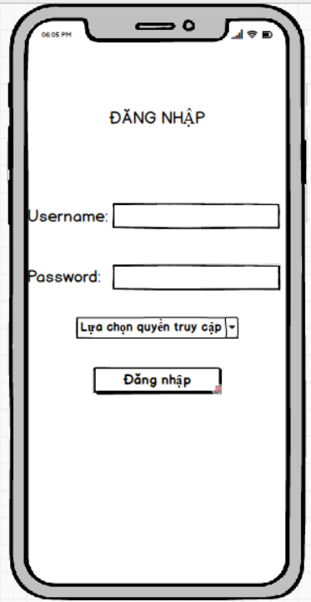

### **Require function**

|  |  |  |  |
| --- | --- | --- | --- |
| **Item** | **description** | **Behavior** | **Response** |
| **Login screen** | **Used to login to work application** | **N/A** | **N/A** |
| **Text “LOG IN”** | Name of the screen | N/A | N/A |
| **Text field "Username"** | Used to enter username | Touch | Will display the keyboard and the user can input |
| **Text field "Password"** | Used to enter password | Touch | Will display the keyboard and the user can input |
| **Button "login"** | Used to go to the main working page | Touch | If the spinner selects the storekeeper and the username and password information is correct in the system, it will go to the Storekeeper Screen. |
| If the spinner selects the store owner and the username and password information is correct in the system, it will go to the Store Home Screen. |
| If the spinner selects a manager and the username and password information is correct in the system, it will go to the Manager Screen. |
| If the spinner selects the invoice processor and the username and password information is correct in the system, it will go to the Bill Processor Screen. |
| If the spinner selects a packer and the username and password information is correct in the system, it will go to the Packer Screen. |

## **Features / Components: Storekeeper Monitor**

### **User interface**

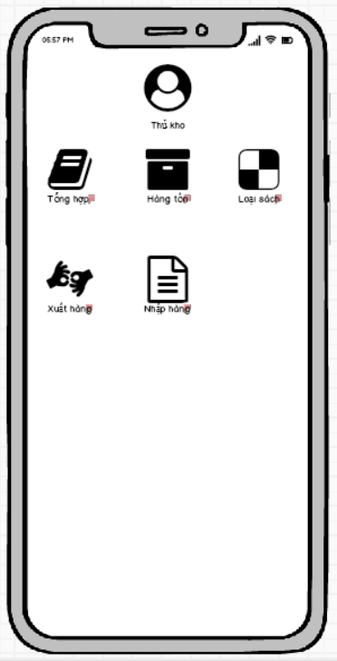

### **Require function**

|  |  |  |  |
| --- | --- | --- | --- |
| **Item** | **Description** | **Behavior** | **Response** |
| **"Storekeeper" screen** | **Includes storekeeper functions** | **N/A** | **N/A** |
| **Button “Synthesis”** | The function of the storekeeper. Use to view the books you sell, add new books. | Click on | Go to the book management page, you can add, delete and edit book information. |
| **Button “Inventory”** | Used to view inventory statistics currently in stock | Click on | Go to stock view page |
| **Button “Book Type”** | Use to see how many books are sold in the store and how many books have that type | Click on | Statistics of books |
| **Button "Export"** | Used to ship goods to the order maker to pack the goods. | Click on | Go to Export page |
| **Button "Import goods"** | Used to import goods for order writers to pack goods. | Click on | Go to the import page. |

## **Features / Components: Book Overview Screen**

### **User interface**

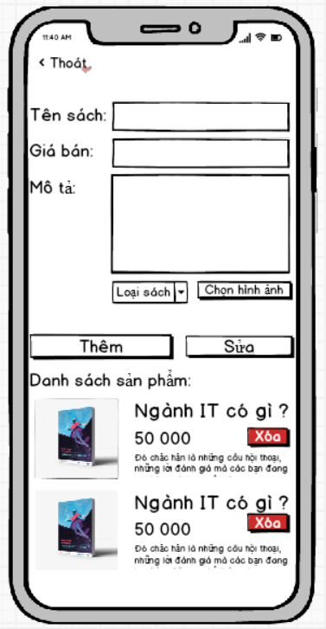

### **Require function**

|  |  |  |  |
| --- | --- | --- | --- |
| **Item** | **Description** | **Behavior** | **Response** |
| **Screen** | This is the screen, the user can manage the book of the store. You can add and delete book information. | N/A | N/A |
| **Button “Exit”** | Used to return to the previous page | Click on | Back to previous page |
| **Textinput “Book Title”** | Enter the title of the book here | Input | Will display the information the user entered |
| **Textinput “Selling Price”** | Enter the selling price of the book | Input | Will display the information the user entered |
| **Textinput “Description”** | Enter a description | Input | Will display the information the user entered |
| **Compobox “Book Type”** | Select type of book | Click on | Users can choose the appropriate type of book. |
| **Button “Select image”** | Image selection | Click on | Users can re-select images for existing books, or add new books |
| **Button “Edit”** | Edit available book information | Click on | When the user clicks on each book, the book's information will be displayed on the textinput, then it is possible to edit the book information and click the edit button, the book information will be corrected. |
| **ListView “Product List”** | See the list of books and can click on it to edit the information. | Click on | You can click to update the content. |
| **Button “Delete”** | Delete the book from the system | Click on | The application will remove the book from the store and will update the list of existing books. |

## **Features / Ingredients: Inventory Statistics**

### **User interface**

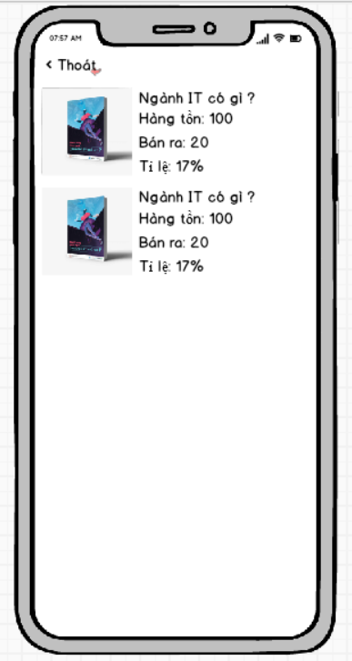

### **Require function**

|  |  |  |  |
| --- | --- | --- | --- |
| **Item** | **Description** | **Behavior** | **Response** |
| **Screen** | Show list of products and sales rate | N/A | N/A |

## **Features / Ingredients: View Book Type**

### **User interface**

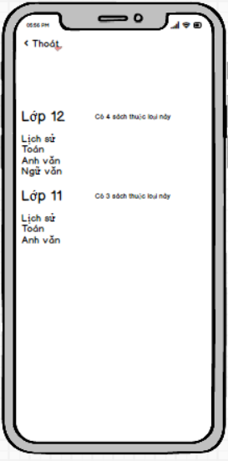

### **Require function**

|  |  |  |  |
| --- | --- | --- | --- |
| **Item** | **Description** | **Behavior** | **Response** |
| **Book type viewing screen** | **To see the types of books and what books I have for sale** | **N/A** | **N/A** |
|  |  |  |  |

## **Features / Components: Export Screen**

### **User interface**

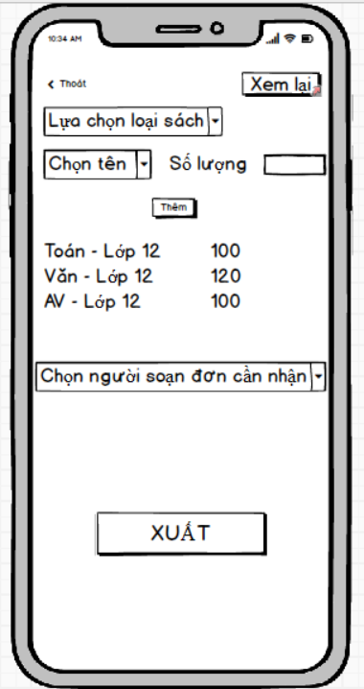

### **Require function**

|  |  |  |  |
| --- | --- | --- | --- |
| **Item** | **Description** | **Behavior** | **Response** |
| **Delivery screen** | **Used for warehouse keeper to deliver goods to shippers** | **N/A** | **N/A** |
| **Combobox “Select type of book”** | **Used for importers to choose the type of books they need to import** | **Tab in** | **The screen will show the types of books that are in stock** |
| **Combobox “Choose a name”** | **Used for importers to choose the title of the book they need to export** | **Tab in** | **The screen will display the titles of the corresponding book type combobox above** |
| **Book title - price** | **Display the books that the importer wants to import more** | **N/A** | **N/A** |
| **Quantity to export** | **Used to input the quantity to be exported to the applicant** | **Tab in** | **A numeric keypad will be displayed for the user to enter the amount** |
| **Export Button** | **To confirm the release of the book for the author** | **Tab in** | **The system will record the action, save this shipment.** |
| **Combobox “Chọn người nhận hàng”** | **This will contain the name of the petitioner** | **Tab in** | **Will display the name of the order maker and the shipper to choose to export to** |
| **Button “Thêm”** | **To add books to the listview the books will appear** | **Tab in** | **The books I choose will be added to the listview below** |

## **Features / Components: Import Screen:**

### **User interface**

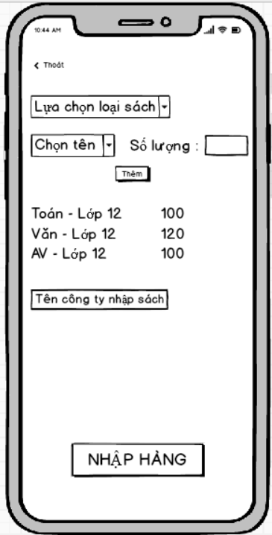

### **Require function**

|  |  |  |  |
| --- | --- | --- | --- |
| **Item** | **Description** | **Behavior** | **Response** |
| **Goods import screen** | **Used to let the storekeeper enter goods into the warehouse** | **N/A** | **N/A** |
| **Combobox “Select type of book”** | **Used for importers to choose the type of books they need to import** | **Tab in** | **The screen will show the types of books available in the store** |
| **Combobox “Choose a name”** | **Used for importers to choose the name of the book they need to import** | **Tab in** | **The screen will display the titles of the corresponding book type combobox above** |
| **Book title - price** | **Display the books that the importer wants to import more** | **N/A** | **N/A** |
| **Quantity** | **User can enter the quantity to be entered** | **Tab in** | **Will display on the numeric keypad for users to input** |
| **TextInput “Tên công côngty nhập sách”** | **Cần nhập tên công ty nhập sách về** | **Tab in** | **Will display on the numeric keypad for users to input** |

## **Features / Components: Import Screen:**

### **User interface**

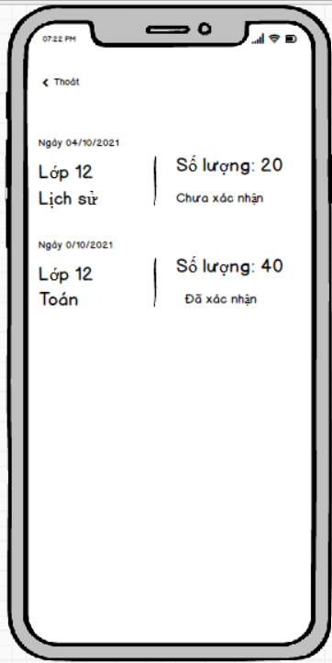

### **Require function**

|  |  |  |  |
| --- | --- | --- | --- |
| **Item** | **Description** | **Behavior** | **Response** |
| **Playback screen** | **Used to let the storekeeper review the goods that have been shipped** | **N/A** | **N/A** |
| **Listview** | **View information about that day's delivery** | **N/A** | **Display information about each date and each type of book published** |
| **Unconfimred** | **The person who prepares the application has not yet entered the form and has received the goods from the exporter** | **N/A** | **Show the storekeeper that he or she has not confirmed receipt of goods from you** |
| **Confirmed** | **The order maker has ticked the button received goods from the storekeeper.** | **N/A** | **Show the storekeeper that the order maker has confirmed receipt of the goods from the storekeeper** |

## **Features / Components: Store Home Screen**

### **User interface**

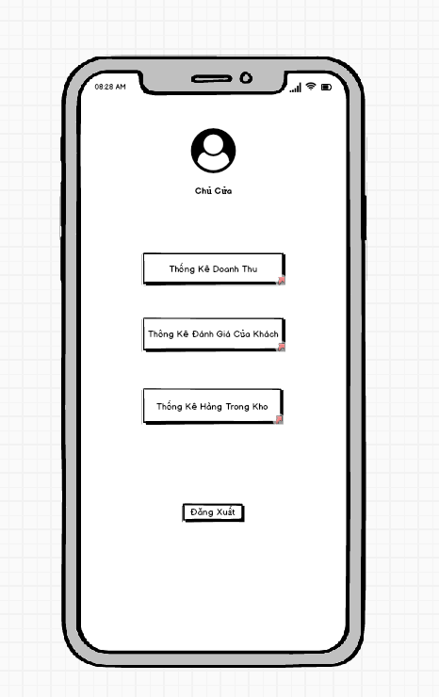

### **Require function**

|  |  |  |  |
| --- | --- | --- | --- |
| **Item** | **Description** | **Behavior** | **Response** |
| **Screen** | Inside the screen include the Administrator's Photo, the administrator's title, the Sales Statistics Button, the Customer Rating Statistics Button, the Inventory Statistics Button and the Log Out Button. | N/A | N/A |
| **Sales Statistics Button** | Click this Button to go to the App's revenue statistics interface. | Click | Go to the revenue statistics interface |
| **Review Statistics Button** | Click this Button to go to the App's evaluation statistics interface. | Click | Go to the evaluation statistics interface |
| **In-stock Statistics Button** | Click this Button to go to the App's inventory statistics interface. | Click | Go to the stock statistics interface |
| **Log Out Button** | Click this Button to log out of the account and switch to the App's login interface. | Click | Log out of your account and return to the login interface |

## **Features / Components: Sales Statistics Screen**

### **User interface**

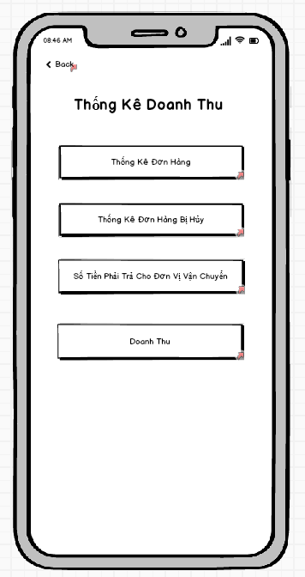

### **Require function**

|  |  |  |  |
| --- | --- | --- | --- |
| **Item** | **Description** | **Behavior** | **Response** |
| **Screen** | Inside the screen include Button Back ,Button Order Statistics, Button Statistics Canceled Orders, Button Amount To Pay For Shipping Units And Button Turnover | Click the Buttons in the screen | N/A |
| **Order Statistics Button** | Click this Button to go to the App's order statistics interface. | Click | Go to the order statistics interface |
| **Canceled Order Statistics Button** | Click this Button to go to the App's canceled order statistics interface. | Click | Go to canceled order statistics interface |
| **Button Amount To Pay For Shipping Unit** | Click this Button to go to the App's billing statistics interface. | Click | Go to the payment statistics interface for the shipping unit |
| **Revenue Button** | Click this Button to switch to App revenue interface. | Click | Go to the revenue interface |
| **Button Back** | Click to return to the Revenue Statistics interface | Click | Go to the store owner interface |

## **Features / Components: Order Statistics Screen**

### **User interface**

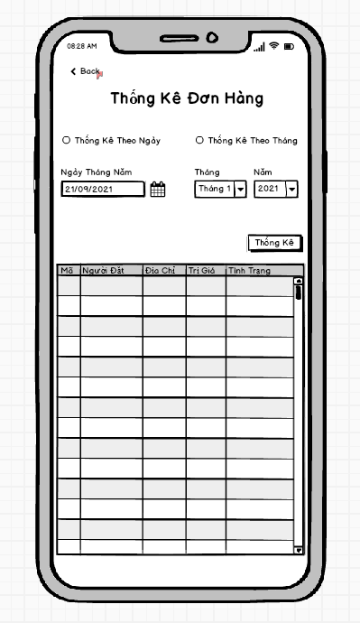

### **Require function**

|  |  |  |  |
| --- | --- | --- | --- |
| **Item** | **Description** | **Behavior** | **Response** |
| **Screen** | Inside the screen include Button Back , TextView Order Statistics, RadioButton Statistics By Date, RadioButton Statistics By Month, DateTime Date May, ComboBox Month, ComboBox Year, Button Statistics,  TextView Date May, TextView Month, TextView Year, Table Statistical Data. Objects such as DateTime Date May, ComboBox Month, ComboBox Year will be locked if one of the two Radio Buttons is not selected for daily statistics and monthly statistics. | Click the Buttons, RadioButtons, ComboBoxes in the screen | N/A |
| **TextView Order Statistics** | Show the title of the interface | Display | Show the title |
| **Text View Date May** | Display title for DateTime object Date May | Display | Show the title |
| **Text View Month** | Display title for ComboBox object Month | Display | Show the title |
| **Text View Year** | Display title for ComboBox object Year | Display | Show the title |
| **RadioButton Statistics By Day** | Tick ​​it to tell the application to list orders by date and to allow the DateTime object to be unlocked. | Check | Set a date-based statistical requirement and unlock the ability to interact with the DateTime object May Day. |
| **RadioButton Monthly Statistics** | Tick ​​to ask the application to list orders by month and allow to unlock the ComboBox Month and ComboBox Year objects . | Check | Set a monthly statistical requirement and unlock the ability to interact with the ComboBox Month and ComboBox Year objects .. |
| **DateTime Date May** | Click on select a specific date to ask the application to order statistics for the selected day. | Click | Displays the date the user has just selected to request order statistics by date |
| **ComboBox Monthly** | Click to select the month in which the user wants to record orders according to the previously selected month | Click | Display the month the user has just selected to request order statistics for the previously selected month |
| **ComboBox Five** | Click to select the Year in which the user wants order statistics according to the previously selected month | Click | Displays the location that the user has just selected to request order statistics for the previously selected month |
| **Stats Button** | Click to start sending the request that the user has set to get the data and fill in the statistical data table | Click | The data is compiled according to the previously set requirements |
| **Statistical Data Table** | This table is used to display the statistical data requested by the user. The table includes columns of information such as, Order ID, Orderer, Address, Value, Status | Display | The data will be displayed inside the table in rows and columns |
| **Button Back** | Click to return to the Revenue Statistics interface | Click | Go to the revenue statistics interface |

## **Features / Components: Canceled Order Statistics Screen**

### **User interface**

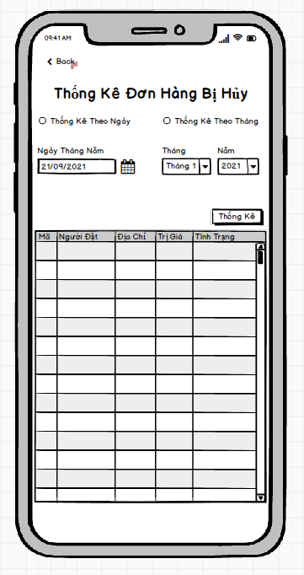

### **Require function**

|  |  |  |  |
| --- | --- | --- | --- |
| **Item** | **Description** | **Behavior** | **Response** |
| **Screen** | Inside the screen include Button Back , TextView Canceled Order Statistics, RadioButton Statistics By Date, RadioButton Statistics By Month, DateTime Date May, ComboBox Month, ComboBox Year, Button Statistics,  TextView Date May, TextView Month, TextView Year, Table Statistical Data. Objects such as DateTime Date May, ComboBox Month, ComboBox Year will be locked if one of the two Radio Buttons is not selected for daily statistics and monthly statistics. | Click the Buttons, RadioButtons, ComboBoxes in the screen | N/A |
| **TextView Canceled Order Statistics** | Show the title of the interface | Display | Show the title |
| **Text View Date May** | Display title for DateTime object Date May | Display | Show the title |
| **Text View Month** | Display title for ComboBox object Month | Display | Show the title |
| **Text View Year** | Display title for ComboBox object Year | Display | Show the title |
| **RadioButton Statistics By Day** | Tick ​​it to tell the application to count canceled orders by date and allow the DateTime object to be unlocked. | Check | Set a date-based statistical requirement and unlock the ability to interact with the DateTime object May Day. |
| **RadioButton Monthly Statistics** | Tick ​​to request the application to list canceled orders by month and allow to unlock the ComboBox Month and ComboBox objects . | Check | Set a monthly statistical requirement and unlock the ability to interact with the ComboBox Month and ComboBox Year objects.. |
| **DateTime Date May** | Click on select a specific date to request the application to list the canceled orders on the selected date. | Click | Displays the date the user has just selected to request statistics of canceled orders by date |
| **ComboBox Monthly** | Click to select the month in which the user wants to record canceled orders according to the previously selected month | Click | Display the month that the user has just selected to request statistics of canceled orders according to the previously selected month |
| **ComboBox Five** | Click to select the Year in which the user wants to record canceled orders according to the previously selected month | Click | Displays the location that the user has just selected to request the statistics of canceled orders according to the previously selected month |
| **Stats Button** | Click to start sending the request that the user has set to get the data and fill in the statistical data table | Click | The data is compiled according to the previously set requirements |
| **Statistical Data Table** | This table is used to display the statistical data requested by the user. The table includes columns of information such as, Order ID, Orderer, Address, Value, Status | Display | The data will be displayed inside the table in rows and columns |
| **Button Back** | Click to return to the Revenue Statistics interface | Click | Go to the revenue statistics interface |

## **Features / Components: Statistical screen of the amount payable to the shipping unit**

### **User interface**

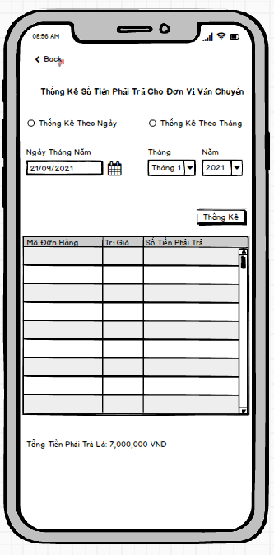

### **Require function**

|  |  |  |  |
| --- | --- | --- | --- |
| **Item** | **Description** | **Behavior** | **Response** |
| **Screen** | Inside the screen include Button Back , TextView Statistics Payable for Shipping Units, RadioButton Statistics By Day, RadioButton Statistics By Month, DateTime May Day, ComboBox Month, ComboBox Year, Button Statistics,  TextView Date May, TextView Month, TextView Year,  TextView Amount To Pay For Shipping, Table Of Statistical Data. Objects such as DateTime Date May, ComboBox Month, ComboBox Year will be locked if one of the two Radio Buttons is not selected for daily statistics and monthly statistics. | Click the Buttons, RadioButtons, ComboBoxes in the screen | N/A |
| **TextView Statistics Payable for Shipping Units** | Show the title of the interface | Display | Show the title |
| **Text View Date May** | Display title for DateTime object Date May | Display | Show the title |
| **Text View Month** | Display title for ComboBox object Month | Display | Show the title |
| **Text View Year** | Display title for ComboBox object Year | Display | Show the title |
| **RadioButton Statistics By Day** | Tick ​​to ask the application to calculate the amount to be transferred to the carrier by date and to allow the DateTime object to be unlocked. | Check | Set a date-based statistical requirement and unlock the ability to interact with the DateTime object May Day. |
| **RadioButton Monthly Statistics** | Tick ​​to ask the application to calculate the amount to be transferred to the shipping unit by month and allows unlocking the ComboBox Month and ComboBox Year objects . | Check | Set a monthly statistical requirement and unlock the ability to interact with the ComboBox Month and ComboBox Year objects.. |
| **DateTime Date May** | Click on select a specific date to ask the application to calculate the amount to be transferred to the shipping unit on the selected date. | Click | Displays the date the user has just selected to request statistics of the amount to be transferred to the carrier according to the selected date |
| **ComboBox Monthly** | Click to select the month in which the user wants to calculate the amount to be transferred to the shipping unit according to the previously selected month | Click | Displays the month that the user has just selected to request statistics of the amount to be transferred to the shipping unit according to the previously selected month |
| **ComboBox Five** | Click to select the Year in which the user wants to calculate the amount to be transferred to the shipping unit according to the previously selected month | Click | Displays the location that the user has just selected to request the statistics of the amount to be transferred to the shipping unit according to the previously selected month |
| **Stats Button** | Click to start sending the request that the user has set to get the data and fill in the statistical data table | Click | The data is compiled according to the previously set requirements |
| **Statistical Data Table** | This table is used to display the statistical data requested by the user. The table includes columns of information such as, Order ID, Value, Amount Payable | Display | The data will be displayed inside the table in rows and columns |
| **Button Back** | Click to return to the Revenue Statistics interface | Click | Go to the revenue statistics interface |
| **TextView Amount To Pay For Shipping** | Display the total payable by day or by month | Display | Show total payable |

## **Features / Components: Sales Statistics Screen**

### **User interface**

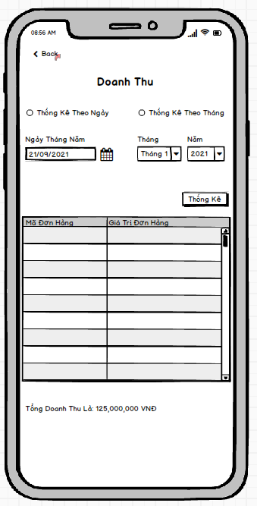

### **Require function**

|  |  |  |  |
| --- | --- | --- | --- |
| **Item** | **Description** | **Behavior** | **Response** |
| **Screen** | Inside the screen include Button Back , TextView Sales Statistics, RadioButton Statistics By Date, RadioButton Statistics By Month, DateTime Date May, ComboBox Month, ComboBox Year, Button Statistics,  TextView Date May, TextView Month, TextView Year,  TextView Total Revenue, Table of Statistical Data. Objects such as DateTime Date May, ComboBox Month, ComboBox Year will be locked if one of the two Radio Buttons is not selected for daily statistics and monthly statistics. | Click the Buttons, RadioButtons, ComboBoxes in the screen | N/A |
| **TextView Revenue** | Show the title of the interface | Display | Show the title |
| **Text View Date May** | Display title for DateTime object Date May | Display | Show the title |
| **Text View Month** | Display title for ComboBox object Month | Display | Show the title |
| **Text View Year** | Display title for ComboBox object Year | Display | Show the title |
| **RadioButton Statistics By Day** | Tick ​​it to ask the application to calculate the revenue by date and allow the DateTime object to be unlocked. | Check | Set a date-based statistical requirement and unlock the ability to interact with the DateTime object May Day. |
| **RadioButton Monthly Statistics** | Tick ​​to request the application to calculate the monthly revenue and allow the ComboBox Month and ComboBox Year objects to be unlocked . | Check | Set a monthly statistical requirement and unlock the ability to interact with the ComboBox Month and ComboBox Year objects.. |
| **DateTime Date May** | Click on select a specific date to ask the application for revenue statistics for the selected day. | Click | Display the date selected by the user to request sales statistics for the selected date |
| **ComboBox Monthly** | Click to select the month in which the user wants the revenue statistics for the previously selected month | Click | Displays the month the user has just selected to request revenue statistics for the previously selected month |
| **ComboBox Five** | Click to select the Year in which the user wants the revenue statistics for the previously selected month | Click | Displays the location that the user has just selected to request revenue statistics for the previously selected month |
| **Stats Button** | Click to start sending the request that the user has set to get the data and fill in the statistical data table | Click | The data is compiled according to the previously set requirements |
| **Statistical Data Table** | This table is used to display the statistical data requested by the user. The table includes columns of information such as, Order ID, Value, Amount Payable | Display | The data will be displayed inside the table in rows and columns |
| **Button Back** | Click to return to the Revenue Statistics interface | Click | Go to the revenue statistics interface |
| **TextView Total Revenue** | Display total sales by day or by month | Display | Show total revenue |

## **Features / Components: Customer Rating Statistics Screen**

### **User interface**

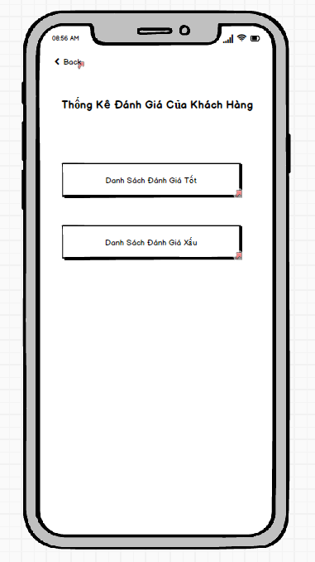

### **Require function**

|  |  |  |  |
| --- | --- | --- | --- |
| **Item** | **Description** | **Behavior** | **Response** |
| **Screen** | Inside the screen include Button Back , TextView Customer Review Statistics, Button, Good Review Button, Bad Review Button | Click the Buttons in the screen | N/A |
| **Good Review Button** | Click this Button to go to the statistics interface of good customer reviews. | Click | Go to the good reviews statistics interface |
| **Bad Rating Statistics Button** | Click this Button to go to the statistics interface of bad customer reviews. | Click | Go to the bad reviews statistics interface |
| **Text View Customer Rating Statistics** | Show the title of the interface | Click | Show interface title |
| **Button Back** | Click to return to the main interface of the store owner authorization | Click | Go to the main interface of the store owner decentralization |

## **Features / Components: Good Rating Stats Monitor**

### **User interface**

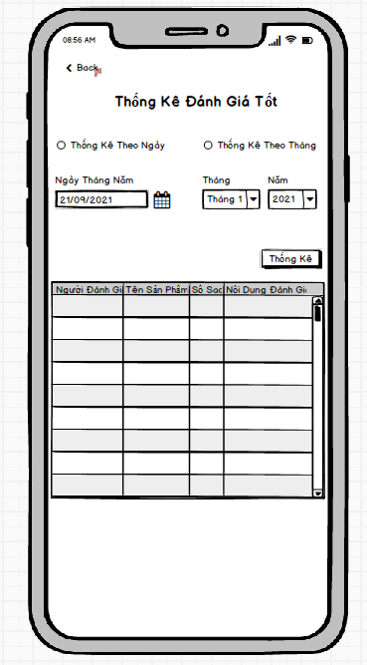

### **Require function**

|  |  |  |  |
| --- | --- | --- | --- |
| **Item** | **Description** | **Behavior** | **Response** |
| **Screen** | Inside the screen include Button Back , TextView Stats Good Rating, RadioButton Statistics By Date, RadioButton Statistics By Month, DateTime Date May, ComboBox Month, ComboBox Year, Button Statistics,  TextView Date May, TextView Month, TextView Year,  TextView Total Revenue, Table of Statistical Data. Objects such as DateTime Date May, ComboBox Month, ComboBox Year will be locked if one of the two Radio Buttons is not selected for daily statistics and monthly statistics. | Click the Buttons, RadioButtons, ComboBoxes in the screen | N/A |
| **TextView Statistics Good Review** | Show the title of the interface | Display | Show the title |
| **Text View Date May** | Display title for DateTime object Date May | Display | Show the title |
| **Text View Month** | Display title for ComboBox object Month | Display | Show the title |
| **Text View Year** | Display title for ComboBox object Year | Display | Show the title |
| **RadioButton Statistics By Day** | Tick ​​it to tell the statistical application to rate well by date and to allow the DateTime object to be unlocked. | Check | Set a date-based statistical requirement and unlock the ability to interact with the DateTime object May Day. |
| **RadioButton Monthly Statistics** | Tick ​​to ask the application to calculate the good rating by month and allow to unlock the ComboBox Month and ComboBox Year objects . | Check | Set a monthly statistical requirement and unlock the ability to interact with the ComboBox Month and ComboBox Year objects.. |
| **DateTime Date May** | Click to select a specific date to ask the application for good evaluation statistics according to the selected date. | Click | Display the date the user has just selected to request good rating statistics according to the selected date |
| **ComboBox Monthly** | Click to select the month in which the user wants good statistics according to the previously selected month | Click | Display the month that the user has just selected to request good review statistics according to the previously selected month |
| **ComboBox Five** | Click to select the Year in which the user wants good review statistics according to the previously selected month | Click | Displays the location that the user has just selected to ask for good rating statistics according to the previously selected month |
| **Stats Button** | Click to start sending the request that the user has set to get the data and fill in the statistical data table | Click | The data is compiled according to the previously set requirements |
| **Statistical Data Table** | This table is used to display the statistical data requested by the user. The table includes columns of information such as, Reviewer, Product Name, Number of Stars, Review Content | Display | The data will be displayed inside the table in rows and columns |
| **Button Back** | Click to return to the Customer Rating Statistics interface | Click | Go to the customer rating statistics interface |

## **Features / Components: Good Rating Stats Monitor**

### **User interface**

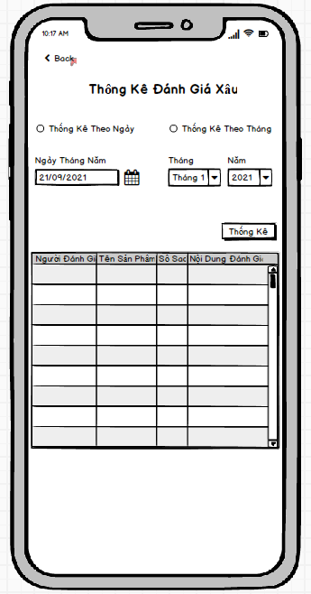

### **Require function**

|  |  |  |  |
| --- | --- | --- | --- |
| **Item** | **Description** | **Behavior** | **Response** |
| **Screen** | Inside the screen include Button Back , TextView Bad Rating Statistics, RadioButton Statistics By Date, RadioButton Statistics By Month, DateTime Date May, ComboBox Month, ComboBox Year, Button Statistics,  TextView Date May, TextView Month, TextView Year,  TextView Total Revenue, Table of Statistical Data. Objects such as DateTime Date May, ComboBox Month, ComboBox Year will be locked if one of the two Radio Buttons is not selected for daily statistics and monthly statistics. | Click the Buttons, RadioButtons, ComboBoxes in the screen | N/A |
| **TextView Bad Rating Stats** | Show the title of the interface | Display | Show the title |
| **Text View Date May** | Display title for DateTime object Date May | Display | Show the title |
| **Text View Month** | Display title for ComboBox object Month | Display | Show the title |
| **Text View Year** | Display title for ComboBox object Year | Display | Show the title |
| **RadioButton Statistics By Day** | Tick ​​it to tell the application to report bad rating by date and to allow the DateTime object to be unlocked. | Check | Set a date-based statistical requirement and unlock the ability to interact with the DateTime object May Day. |
| **RadioButton Monthly Statistics** | Tick ​​to ask the application to calculate the bad rating by month and allow to unlock the ComboBox Month and ComboBox Year objects . | Check | Set a monthly statistical requirement and unlock the ability to interact with the ComboBox Month and ComboBox Year objects.. |
| **DateTime Date May** | Click to select a specific date to ask the application to report bad reviews according to the selected date. | Click | Displays the date the user has just selected to request bad review statistics according to the selected date |
| **ComboBox Monthly** | Click to select the month in which the user wants the bad rating statistics according to the previously selected month | Click | Displays the month the user has just selected to request bad review statistics according to the previously selected month |
| **ComboBox Five** | Click to select the Year in which the user wants bad rating statistics according to the previously selected month | Click | Display the location that the user has just selected to ask for bad review statistics according to the previously selected month |
| **Stats Button** | Click to start sending the request that the user has set to get the data and fill in the statistical data table | Click | The data is compiled according to the previously set requirements |
| **Statistical Data Table** | This table is used to display the statistical data requested by the user. The table includes columns of information such as, Reviewer, Product Name, Number of Stars, Review Content | Display | The data will be displayed inside the table in rows and columns |
| **Button Back** | Click to return to the Customer Rating Statistics interface | Click | Go to the customer rating statistics interface |

## **Features / Components: Inventory Monitor**

### **User interface**

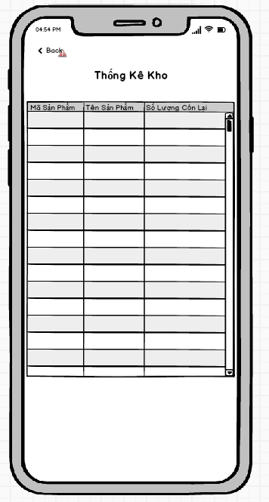

### **Require function**

|  |  |  |  |
| --- | --- | --- | --- |
| **Item** | **Description** | **Behavior** | **Response** |
| **Screen** | Inside the screen include Button Back , TextView Inventory Statistics, Table of Statistical Data | Click the Buttons in the screen | N/A |
| **Statistical Data Table** | This table is used to display statistical data as soon as you enter the interface. The table includes columns of information such as Product Code, Product Name, Remaining Quantity | Display | The data will be displayed inside the table in rows and columns |
| **Text View Statistics** | Show the title of the interface | Click | Show interface title |
| **Button Back** | Click to return to the Shop Owner interface | Click | Go to inventory statistics interface |

## **Features / Components: Handler Monitor**

### **User interface**

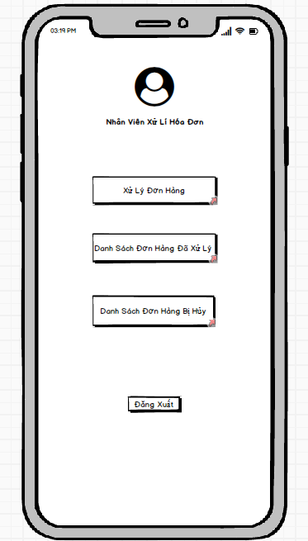

### **Require function**

|  |  |  |  |
| --- | --- | --- | --- |
| **Item** | **Description** | **Behavior** | **Response** |
| **Screen** | Inside the screen include the Administrator's Photo, the administrator's title, the Order Processing Button, the Processed Order List Button, the Canceled Order List Button and the Log Out Button. | Click the Buttons in the screen | N/A |
| **Order Processing Button** | Click this Button to go to the App's order processing interface. | Click | Go to the order processing interface |
| **Processed Order List Button** | Click this Button to go to the App's processed orders interface. | Click | Go to the processed orders interface |
| **Canceled Order List Button** | Click this Button to go to the App's canceled order list interface. | Click | Go to the canceled order list interface |
| **Log Out Button** | Click this Button to log out of the account and switch to the App's login interface. | Click | Log out of your account and return to the login interface |

## **Features / Components: Order Processing Screen**

### **User interface**

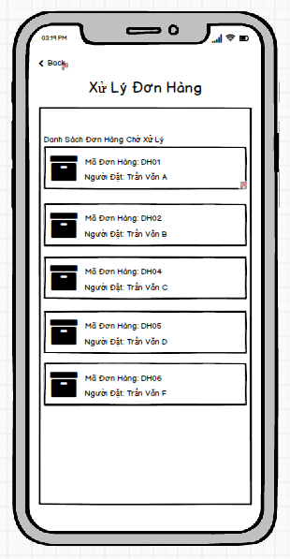

### **Require function**

|  |  |  |  |
| --- | --- | --- | --- |
| **Item** | **Description** | **Behavior** | **Response** |
| **Screen** | Inside the screen includes Button Back, TextView Order Processing, TextView List of Pending Orders and ViewGroups with information of pending orders. | Click the Buttons in the screen | N/A |
| **TextView Order Processing** | Show title for interface | Display | Show interface title |
| **TextView List of Pending Orders** | Display title for pending order ViewGroup objects | Display | Show title for list of pending orders |
| **Log Out Button** | Click this Button to log out of the account and switch to the App's login interface. | Click | Log out of your account and return to the login interface |
| **ViewGroup Pending Orders** | Inside View Group includes order icon, Order ID TextView, Orderer TextView. With each ViewGroup representing a pending order, clicking on one of the ViewGroups will take you to the order details page that the ViewGroup displays. | Click | Go to order details page |
| **Button Back** | Click to return to the handler interface | Click | Go to handler interface |

## **Features / Components: Order Detail Screen**

### **User interface**

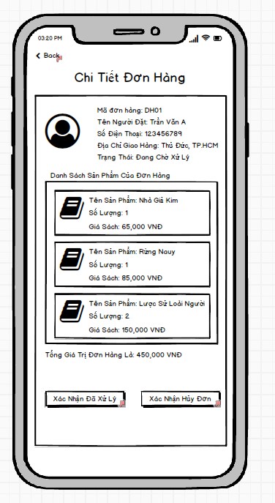

### **Require function**

|  |  |  |  |
| --- | --- | --- | --- |
| **Item** | **Description** | **Behavior** | **Response** |
| **Screen** | Inside the screen include the Back Button, Order Detail TextView, Order Details ViewGroup, Order Product Information ViewGroups, Product List TextView, Order Total Value TextView, Processed Confirmation Button Reason, Confirm Order Cancellation | Click the Buttons in the screen | N/A |
| **TextView Order Details** | Show title for interface | Display | Show interface title |
| **TextView Product List** | Display the title for the product ViewGroup objects of the order | Display | Display title for ViewGroup objects |
| **Text View Total Order Value** | Display the total value of the order | Display | Display the total value of the order |
| **ViewGroup Booking Information** | Inside the View Group includes the person's account avatar, Order ID TextView, Orderer Name TextView, Phone Number TextView, Address TextView, Order Status TextView. This ViewGroup is used to display information of the person placing the order. | Display | Display information of the person placing the order |
| **ViewGroup product information of the order** | Inside the View Group include the product's photo, TextView Product Name, TextView Number of User Sets, TextView Price Of Product. This ViewGroup is used to display detailed information of each product inside the order | Display | Display product information inside the order |
| **Confirmation Processed Button** | Click to send confirmation that this order has been processed | Click | Show processing confirmation message, this message allows to choose yes or no. If you select yes, a confirmation message of successful order processing will be displayed and a Close Button will close the message. If you choose not, it will close the notification and do nothing |
| **Cancellation Confirmation Button** | Click to send confirmation that this order will be cancelled | Click | Show a confirmation message to cancel the order, this message allows you to choose yes or no. If you choose yes, a confirmation message will be displayed to confirm the successful order cancellation and a Close Button to close the notification. If you choose not, it will close the notification and do nothing |
| **Button Back** | Click to return to the order processing interface | Click | Go to the order processing interface |

## **Features / Components: Canceled Order List Screen**

### **User interface**

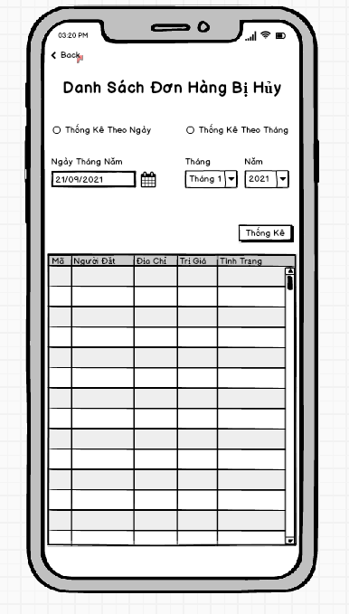

### **Require function**

|  |  |  |  |
| --- | --- | --- | --- |
| **Item** | **Description** | **Behavior** | **Response** |
| **Screen** | Inside the screen include Button Back , TextView Statistics Canceled Order List, RadioButton Statistics By Date, RadioButton Statistics By Month, DateTime Date May, ComboBox Month, ComboBox Year, Button Statistics,  TextView Date May, TextView Month, TextView Year, Table Statistical Data. Objects such as DateTime Date May, ComboBox Month, ComboBox Year will be locked if one of the two Radio Buttons is not selected for daily statistics and monthly statistics. | Click the Buttons, RadioButtons, ComboBoxes in the screen | N/A |
| **TextView List of Canceled Orders** | Show the title of the interface | Display | Show the title |
| **Text View Date May** | Display title for DateTime object Date May | Display | Show the title |
| **Text View Month** | Display title for ComboBox object Month | Display | Show the title |
| **Text View Year** | Display title for ComboBox object Year | Display | Show the title |
| **RadioButton Statistics By Day** | Tick ​​it to tell the application to count canceled orders by date and allow the DateTime object to be unlocked. | Check | Set a date-based statistical requirement and unlock the ability to interact with the DateTime object May Day. |
| **RadioButton Monthly Statistics** | Tick ​​to request the application to list canceled orders by month and allow to unlock the ComboBox Month and ComboBox objects . | Check | Set a monthly statistical requirement and unlock the ability to interact with the ComboBox Month and ComboBox Year objects.. |
| **DateTime Date May** | Click on select a specific date to request the application to list the canceled orders on the selected date. | Click | Displays the date the user has just selected to request statistics of canceled orders by date |
| **ComboBox Monthly** | Click to select the month in which the user wants to record canceled orders according to the previously selected month | Click | Display the month that the user has just selected to request statistics of canceled orders according to the previously selected month |
| **ComboBox Five** | Click to select the Year in which the user wants to record canceled orders according to the previously selected month | Click | Displays the location that the user has just selected to request the statistics of canceled orders according to the previously selected month |
| **Stats Button** | Click to start sending the request that the user has set to get the data and fill in the statistical data table | Click | The data is compiled according to the previously set requirements |
| **Statistical Data Table** | This table is used to display the statistical data requested by the user. The table includes columns of information such as, Order ID, Orderer, Address, Value, Status | Display | The data will be displayed inside the table in rows and columns |
| **Button Back** | Click to return to the handler interface | Click | Go to handler interface |

## **Features / Components: Processed Order List Screen**

### **User interface**

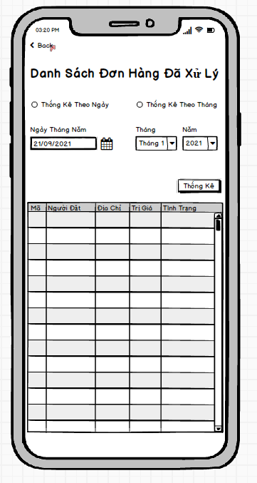

### **Require function**

|  |  |  |  |
| --- | --- | --- | --- |
| **Item** | **Description** | **Behavior** | **Response** |
| **Screen** | Inside the screen include Button Back , TextView List of Processed Orders, RadioButton Statistics By Date, RadioButton Statistics By Month, DateTime Date May, ComboBox Month, ComboBox Year, Button Statistics,  TextView Date May, TextView Month, TextView Year, Table Statistical Data. Objects such as DateTime Date May, ComboBox Month, ComboBox Year will be locked if one of the two Radio Buttons is not selected for daily statistics and monthly statistics. | Click the Buttons, RadioButtons, ComboBoxes in the screen | N/A |
| **TextView List of Processed Orders** | Show the title of the interface | Display | Show the title |
| **Text View Date May** | Display title for DateTime object Date May | Display | Show the title |
| **Text View Month** | Display title for ComboBox object Month | Display | Show the title |
| **Text View Year** | Display title for ComboBox object Year | Display | Show the title |
| **RadioButton Statistics By Day** | Tick ​​it to ask the application to list processed orders by date and to allow the DateTime object to be unlocked. | Check | Set a date-based statistical requirement and unlock the ability to interact with the DateTime object May Day. |
| **RadioButton Monthly Statistics** | Tick ​​to ask the application to list the processed orders by month and allow the ComboBox Month and ComboBox Year objects to be unlocked . | Check | Set a monthly statistical requirement and unlock the ability to interact with the ComboBox Month and ComboBox Year objects.. |
| **DateTime Date May** | Click on select a specific date to ask the application to list the orders processed in the selected day. | Click | Display the date the user has just selected to request the processed order statistics by date |
| **ComboBox Monthly** | Click to select the month in which the user wants the processed order statistics according to the previously selected month | Click | Displays the month the user has just selected to request the processed order statistics according to the previously selected month |
| **ComboBox Five** | Click to select the Year in which the user wants to record the processed orders according to the previously selected month | Click | Displays the location that the user has just selected to ask for the processed order statistics according to the previously selected month |
| **Stats Button** | Click to start sending the request that the user has set to get the data and fill in the statistical data table | Click | The data is compiled according to the previously set requirements |
| **Statistical Data Table** | This table is used to display the statistical data requested by the user. The table includes columns of information such as, Order ID, Orderer, Address, Value, Status | Display | The data will be displayed inside the table in rows and columns |
| **Button Back** | Click to return to the handler interface | Click | Go to handler interface |

## **Features/Components: Management Screen**

### **User interface**

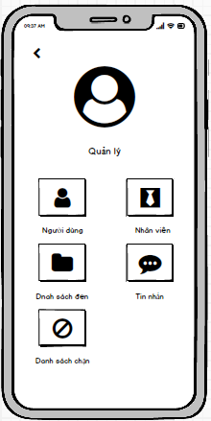

### **Require function**

|  |  |  |  |
| --- | --- | --- | --- |
| **Item** | **Description** | **Action** | **Response** |
| **Management screen** | Management screen with 5 buttons, 1 TextView  :  ●          User  ●          Block  ●          Employee  ●          Blacklist  ●          Message  ●         Manage | N/A | N/A |
| **User button** | Go to the user account management screen | Tap on User button | The user management screen appears |
| **Block button** | Go to the user account management screen | Tap on Block button | The user blocking management screen appears |
| **Employee button** | Go to employee account management screen | Tap on Employee button | Employee management screen appears |
| **Blacklist button** | Go to the blacklist account management screen | Tap on Blacklist button | Blacklist management screen appears |
| **Message button** | Go to the message management screen | Tap on Message button | The message management screen appears |
| **Manage TextView** | Display the name of the screen | N/A | N/A |

## **Features/Components: User Management Screen**

### **User interface**

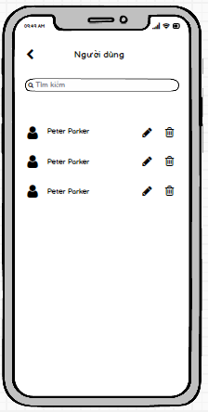

### **Require function**

|  |  |  |  |
| --- | --- | --- | --- |
| **Item** | **description** | **Action** | **Response** |
| **User management screen** | The user management screen has 3 buttons, 1 search box:  ●          Delete  ●          Update  ●          Back  ●          Search Box | N/A | N/A |
| **Update button** | Update user information | Tap on Update button | Go to user account update screen |
| **Delete button** | Delete user account | Tap on Delete button | Delete user account |
| **Back button** | Back to screen | Tap on Back button | Back to Management screen |
| **Search Box** | Search for users | Tap on Search Box | Search for users |

## **Features/Components: User Update Screen**

### **User interface**

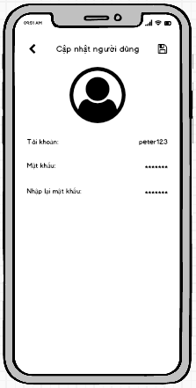

### **Require function**

|  |  |  |  |
| --- | --- | --- | --- |
| **Item** | **Description** | **Action** | **Response** |
| **User Update Screen** | Update user screen has 2 buttons ,3 Edit Text:  ●          Save  ●          Back  ●          Username  ●          Password  ●          RePassword | N/A | N/A |
| **Save** | Save user information | Tap on Save button | Save the account, return to the user management screen |
| **Username edittext** | Enter user account | Tap on Username edittext | Enter user account |
| **Password edittext** | Enter user password | Tap on Password edittext | Enter user password |
| **Re-enter Password edittext** | Enter the password | Tap on Re-enter Password edittext | Enter the password |

## **Features/Components: Blacklist Screen**

### **User interface**

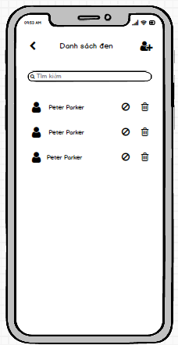

### **Require function**

|  |  |  |  |
| --- | --- | --- | --- |
| **Item** | **Description** | **Action** | **Response** |
| **Blacklist screen** | The  blacklist screen has 4 buttons, 1 search box:  ●          Add  ●          Delete  ●          Block  ●          Back  ●          Search Box | N/A | N/A |
| **Add button** | Add to a user account | Tap on Add button | Go to add user screen |
| **Delete button** | Delete user account | Tap on Delete button | Remove user account from blacklist |
| **Back button** | Back to screen | Tap on Back button | Back to Management screen |
| **Search Box** | Search for users | Tap on Search Box | Search for users |
| **Block button** | Block users | Tap on Block button | Block user accounts |

## **Features/Components:Add Blacklist Screen**

### **User interface**

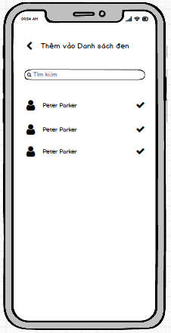

### **Require function**

|  |  |  |  |
| --- | --- | --- | --- |
| **Item** | **description** | **Action** | **Response** |
| **Add Blacklist screen** | Add blacklist has 2 buttons ,1 search box:  ●          Check  ●          Back  ●          Search Box | N/A | N/A |
| **Check button** | Add a user account to the blacklist | Tap on Add button | Add a user account to the blacklist |
| **Back button** | Back to screen | Tap on Back button | Back to Blacklist screen |
| **Search Box** | Search for users | Tap on Search Box | Search for users |

## **Features/Components: Block Screen**

### **User interface**

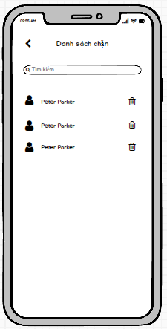

### **Require function**

|  |  |  |  |
| --- | --- | --- | --- |
| **Item** | **description** | **Action** | **Response** |
| **Block screen** | Block screen has 2 buttons ,1 search box:  ●          Delete  ●          Back  ●          Search Box | N/A | N/A |
| **Delete button** | Remove account from block list | Tap on Add button | Remove account from block list |
| **Back button** | Back to screen | Tap on Back button | Back to Management screen |
| **Search Box** | Search for users | Tap on Search Box | Search for users on the block list |

## **Features/Components: Massage Screen**

### **User interface**

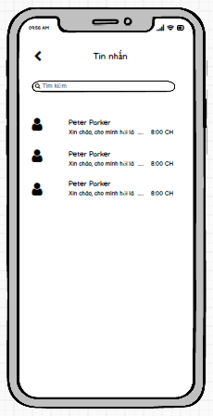

### **Require function**

|  |  |  |  |
| --- | --- | --- | --- |
| **Item** | **description** | **Action** | **Response** |
| **Massage screen** | Message screen has 2 buttons ,1 search box,1 Listview:  ●          Message Listview  ●          Back  ●          Search Box | N/A | N/A |
| **Message listview** | Show list of chats | Tap on Add button | Tap on the chat to go to the chat screen |
| **Back button** | Back to screen | Tap on Back button | Back to Management screen |
| **Search Box** | Search for users | Tap on Search Box | Search chat |

## **Features/Components: Chat Screen**

### **User interface**

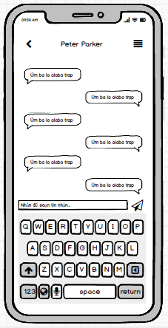

### **Require function**

|  |  |  |  |
| --- | --- | --- | --- |
| **Item** | **description** | **Action** | **Response** |
| **Employee screen** | Employee screen has 2 buttons ,1 Edit text:  ●          Back  ●          Edit Text  ●          Send | N/A | N/A |
| **Chat EditText** | Enter the message you want to send in the chat | Tap on Update button | Go to employee information update screen |
| **Send button** | Send a message you're composing | Tap on Delete button | Delete employee information |
| **Back button** | Back to screen | Tap on Back button | Back to Massage screen |

## **Features/Components: Employee Screen**

### **User interface**

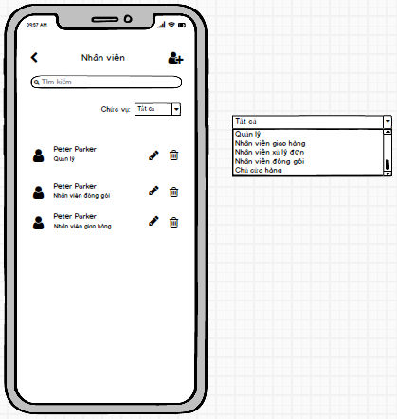

### **Require function**

|  |  |  |  |
| --- | --- | --- | --- |
| **Item** | **description** | **Action** | **Response** |
| **Employee screen** | Employee screen has 4 buttons ,1 Search Box,1 Combo Box,1 TextView:  ●          Add  ●          Delete  ●          Update  ●          Back  ●          Search Box  ●          Position  ●          Position Combo Box | N/A | N/A |
| **Add button** | Add to employee | Tap on Add button | Add a new employee |
| **Update button** | Update employee information | Tap on Update button | Go to employee information update screen |
| **Delete button** | Delete employee | Tap on Delete button | Delete employee information |
| **Back button** | Back to screen | Tap on Back button | Back to Management screen |
| **Search Box** | Looking for employees | Tap on Search Box | Looking for employees |
| **Roles TextView** | Show name of combo box | N/A | N/A |
| **Roles Combo Box** | Filter the list of employees by role | Select roles All | Show All roles on the Combo Box |
| Select roles Management | Show Management roles on the Combo Box |
| Select roles Shipper | Show Shipper roles on the Combo Box |
| Select roles Order handled | Show Order handle roles on the Combo Box |
| Select roles Packer | Show Packer roles on the Combo Box |
| Select roles Shop Owner | Show Shop Owner roles on the Combo Box |

## **Features/Components:Add Employee Screen**

### **User interface**

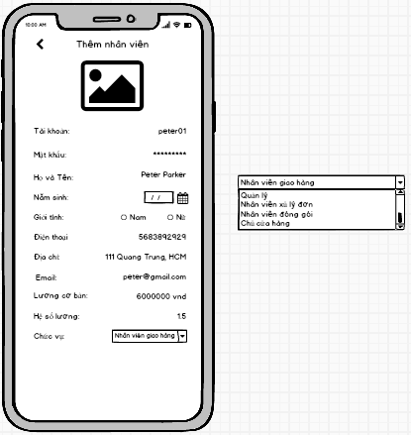

### **Require function**

|  |  |  |  |
| --- | --- | --- | --- |
| **Item** | **description** | **Action** | **Response** |
| **Add Employee screen** | Add Employee screen has 2 Button,2 Radio Button ,8 Edit Text,1 Date Chooser,1 Combo Box:  ●          Save  ●          Username  ●          Password  ●          Back  ●          Name  ●          Birth of day  ●          Gender  ●          Phone  ●          Address  ●          Email  ●          Basic salary  ●          Coefficient  ●          Roles | N/A | N/A |
| **Name edittext** | Enter employee name | Tap on Name edittext | Save information |
| **Birth of day edittext** | Enter date of birth | Tap on Birth of day date chooser | Back to Employee screen |
| **Gender radio button** | Choose your gender | Tap on Male radio button or Female radio button | Gender selection |
| **Phone edittext** | Enter your phone number | Tap on Phone edittext | Enter your phone number |
| **Address edittext** | Enter address | Tap on Address edittext | Enter address |
| **Email edittext** | Enter your email address | Tap on Email edittext | Enter your email address |
| **Basic salary edittext** | Enter basic salary | Tap on Basic salary edittext | Enter basic salary |
| **Coefficient edittext** | Enter salary coefficient | Tap on Coefficient edittext | Enter salary coefficient |
| **Roles edittext** | Enter the position for the employee | Tap on Position **e**text | Enter the position for the employee |
| **Username Edit Text** | Enter account | Tap on Username EditText | Enter the employee's account name |
| **Password Edit Text** | Enter password | Tap on Password EditText | Enter the employee's password |
| **Save Button** | Save the newly created account | Tap on Save Button | Save the newly created account and return to the staff management screen |

## **Features/Components:Update Employee Screen**

### **User interface**

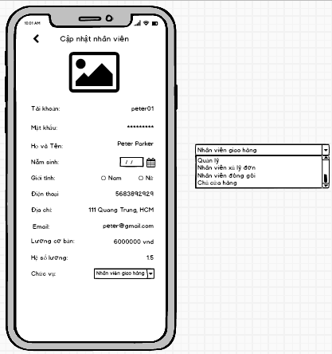

### **Require function**

|  |  |  |  |
| --- | --- | --- | --- |
| **Item** | **description** | **Action** | **Response** |
| **Update Employee screen** | Update Employee screen has 2 Button,2 Radio Button ,8 Edit Text,1 Date Chooser, 1 Combo Box:  ●          Save  ●          Back  ●          Username  ●          Password  ●          Name  ●          Birth of day  ●          Gender  ●          Phone  ●          Address  ●          Email  ●          Basic salary  ●          Coefficient  ●          Roles | N/A | N/A |
| **Name edittext** | Enter employee name | Tap on Name edittext | Save information |
| **Birth of day edittext** | Enter date of birth | Tap on Birth of day date chooser | Back to Employee screen |
| **Gender radio button** | Choose your gender | Tap on Male radio button or Female radio button | Gender selection |
| **Phone edittext** | Enter your phone number | Tap on Phone edittext | Enter your phone number |
| **Address edittext** | Enter address | Tap on Address edittext | Enter address |
| **Email edittext** | Enter your email address | Tap on Email edittext | Enter your email address |
| **Basic salary edittext** | Enter basic salary | Tap on Basic salary edittext | Enter basic salary |
| **Coefficient edittext** | Enter salary coefficient | Tap on Coefficient edittext | Enter salary coefficient |
| **Roles Combo Box** | Choose a role for an employee | Select roles on the Combo Box | Choose a role for an employee |
| **Username Edit Text** | Enter account | Tap on Username EditText | Enter the employee's account name |
| **Password Edit Text** | Enter password | Tap on Password EditText | Enter the employee's password |
| **Save Button** | Save the updated information | Tap on Save Button | Save the updated information and return to the employee management screen |

## **Features/Components:Record Employee Screen**

### **User interface**

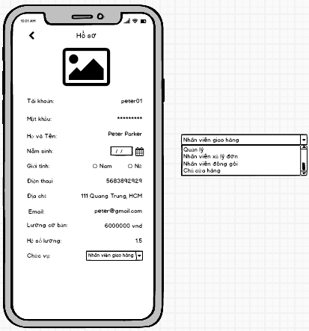

### **Require function**

|  |  |  |  |
| --- | --- | --- | --- |
| **Item** | **description** | **Action** | **Response** |
| **Record Employee screen** | Record Employee screen has 2 Button,2 Radio Button ,8 TextView,1 Date Chooser, 1 Combo Box:  ●          Save  ●          Back  ●          Username  ●          Password  ●          Name  ●          Birth of day  ●          Gender  ●          Phone  ●          Address  ●          Email  ●          Basic salary  ●          Coefficient  ●          Roles | N/A | N/A |
| **Name TextView** | Show employee name | N/A | N/A |
| **Birth of day Date chooser** | Show date of birth | N/A | N/A |
| **Gender radio button** | Show gender | N/A | N/A |
| **Phone TextView** | Show phone number | N/A | N/A |
| **Address TextView** | Show address | N/A | N/A |
| **Email TextView** | Show email | N/A | N/A |
| **Basic salary TextView** | Show base salary | N/A | N/A |
| **Coefficient TextView** | Show salary coefficient | N/A | N/A |
| **Roles Combo Box** | Display the position of the employee | N/A | N/A |
| **Username TextView** | Show account name | N/A | N/A |
| **Password TextView** | Show lost password as ****** | N/A | N/A |
| **Back Button** | Go back to the employee management screen | Tap on Back Button | Employee management screen appears |

## **Features/Components: Packed Screen**

### **User interface**

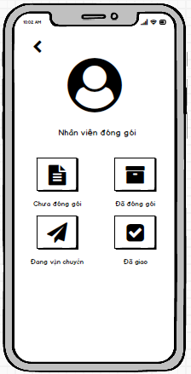

### **Require function**

|  |  |  |  |
| --- | --- | --- | --- |
| **Item** | **description** | **Action** | **Response** |
| **Packing management screen** | The packaging management screen has 4 buttons:  ●          Unpacked  ●          Packaged  ●          In transit  ●          Delivered | N/A | N/A |
| **Unpacked button** | Go to the unpacked order management screen | Tap on User button | Unpacked product screen appears |
| **Packaged button** | Go to the packaged order management screen | Tap on Block button | The packaged screen management screen appears |
| **In transit button** | Go to the shipping order management screen | Tap on Employee button | The shipping order management screen appears |
| **Delivered button** | Go to the delivered order management screen | Tap on Blacklist button | The screen to manage the list of delivered orders appears |

## **Features/Components: Unpacked Screen**

### **User interface**

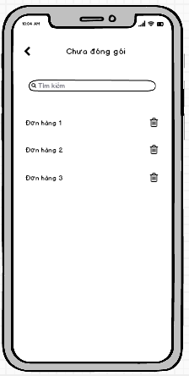

### **Require function**

|  |  |  |  |
| --- | --- | --- | --- |
| **Item** | **description** | **Action** | **Response** |
| **Unpacked screen** | The unpacked screen has 2 buttons, 1 search box, 1 ListView:  ●          Order ListView  ●          Delete  ●          Back  ●          Search Box | N/A | N/A |
| **Order ListView** | Show order list | Tap on View Item | Tap on the order name to go to the order details screen |
| **Delete button** | Delete pending orders | Tap on Delete button | Remove order from listview |
| **Back button** | Back to screen | Tap on Back button | Back to Packer screen |
| **Search Box** | Search for pending orders | Tap on Search Box | Search for orders by name |

## **Features/Components: Order Detail Screen**

### **User interface**

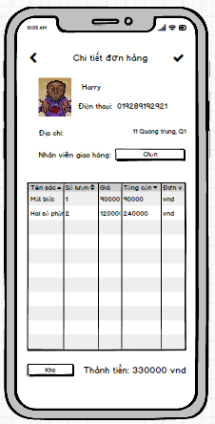

### **Require function**

|  |  |  |  |
| --- | --- | --- | --- |
| **Item** | **description** | **Action** | **Response** |
| **Order Detail screen** | Order details screen has 3 buttons ,1 Data Grid,1 TextView:  ●          Check  ●          Order detail  ●          Total  ●          Back  ●         Storehouse | N/A | N/A |
| **Order detail datagrid** | Show order list | N/A | Show details of products in the order |
| **Check button** | Complete packing | Tap on Check button | Turn your order into a packed state |
| **Back button** | Back to screen | Tap on Back button | Back to Packer screen |
| **Storehouse button** | Check goods in stock | Tap on Storehouse button | The inventory management screen appears |
| **Total TextView** | Show the total amount of the invoice | N/A | Show the total amount of the invoice |

## **Features/Components: Storehouse Screen**

### **User interface**

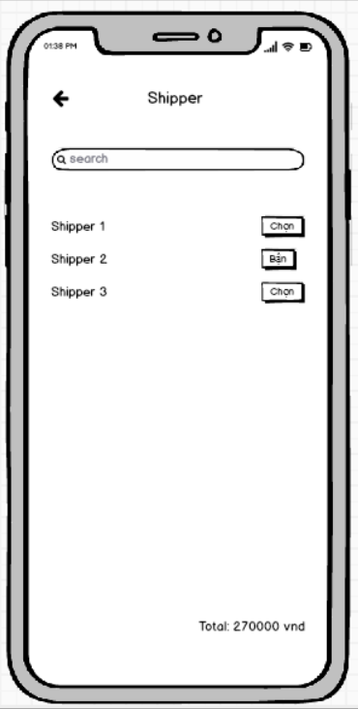

### **Require function**

|  |  |  |  |
| --- | --- | --- | --- |
| **Item** | **Description** | **Action** | **Response** |
| **Screen** | Choose a shipper for the order | N/A | N/A |
| **Listview shipper** | Choose 1 of the shippers | Click | That shipper will have a notice to pick up the order and deliver |
| **Select Button** | Used to choose that shipper | Click | That shipper will become busy |
| **Textinput search** | Used to search shipper by name | Input text | Listview will display the respective shippers |

## **Features/Components: Storehouse Screen**

### **User interface**

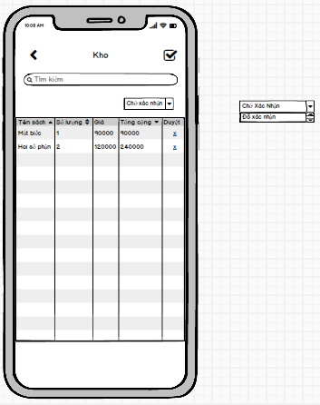

### **Require function**

|  |  |  |  |
| --- | --- | --- | --- |
| **Item** | **Description** | **Action** | **Response** |
| **Order Detail screen** | Storehouse screen has 3 buttons ,1 Data Grid,2 Checkbox,1 Combo Box:  ●          Check All  ●          Check  ●          DataGid  ●          Back  ●         Search Box | N/A | N/A |
| **Order detail datagrid** | Show order list | N/A | Show details of products in the order |
| **Check button** | Confirm that the goods have been received from the warehouse | Tap on Check button | Confirm that the goods have been received from the warehouse |
| **Back button** | Back to screen | Tap on Back button | Back to Packer screen |
| **Check all button** | Confirm that all goods have been received from the warehouse | Tap on Check All button | Confirm that all goods have been received from the warehouse |
| **Search Box** | Search for pending orders | Tap on Search Box | Search for orders by name |

## **Features/Components: Packaged Screen**

### **User interface**

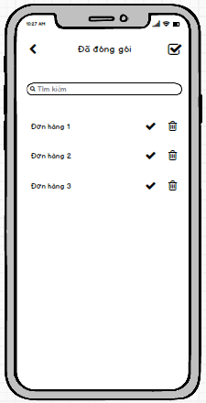

### **Require function**

|  |  |  |  |
| --- | --- | --- | --- |
| **Item** | **description** | **Action** | **Response** |
| **Packaged screen** | The packaged order management screen has 4 buttons, 1 search box, 1 ListView:  ●          Order ListView  ●          Delete  ●          Back  ●          Search Box  ●          Check  ●          Check All | N/A | N/A |
| **Order ListView** | Show the list of packed orders | Tap on View Item | List of packed orders, click on the order wall to see details |
| **Delete button** | Delete order | Tap on Delete button | Remove order from listview |
| **Back button** | Back to screen | Tap on Back button | Back to Packer screen |
| **Search Box** | Order search | Tap on Search Box | Single search by code |
| **Check button** | Delivery of orders | Tap on Check button | Change order to delivery status |
| **Check All button** | Delivery of orders | Tap on Check All button | Move all orders to shipping status |

## **Features/Components: In Transit Screen**

### **User interface**

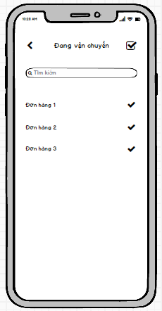

### **Require function**

|  |  |  |  |
| --- | --- | --- | --- |
| **Item** | **description** | **Action** | **Response** |
| **In Transit screen** | The screen of managing orders being delivered has 3 buttons, 1 search box, 1 ListView:  ●          Order ListView  ●          Back  ●          Search Box  ●          Check  ●          Check All | N/A | N/A |
| **Order ListView** | Display the list of orders being delivered | Tap on View Item | List of orders being delivered, click on the order wall to see details |
| **Back button** | Back to screen | Tap on Back button | Back to Packer screen |
| **Search Box** | Order search | Tap on Search Box | Single search by code |
| **Check button** | Confirmed successful delivery | Tap on Check button | The order has been successfully transferred to the delivery status |
| **Check All button** | Confirmed successful delivery | Tap on Check All button | Change all orders to successful delivery |

## **Features/Components: Delivered Screen**

### **User interface**

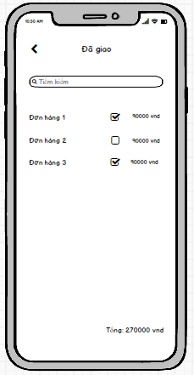

### **Require function**

|  |  |  |  |
| --- | --- | --- | --- |
| **Item** | **description** | **Action** | **Response** |
| **Delivered screen** | Delivered order management screen has 2 buttons, 1 search box, 1 ListView:  ●          Order ListView  ●          Back  ●          Search Box  ●          Checkbox | N/A | N/A |
| **Order ListView** | Delivered order management screen | Tap on View Item | List of delivered orders, tap the check button to confirm that you have received money from the delivery person |
| **Back button** | Back to screen | Tap on Back button | Back to Packer screen |
| **Search Box** | Order search | Tap on Search Box | Single search by code |
| **Check button** | Confirmed successful delivery | Tap on Check button | Confirm the order has been delivered successfully and receive money from the carrier |

## **Features / Components: Choose Shiper Screen**

### **User interface**



### **Require function**

|  |  |  |  |
| --- | --- | --- | --- |
| **Item** | **Description** | **Behavior** | **Response** |
| **Screen** | Choose a shipper for the order | N/A | N/A |
| **Listview shipper** | Choose 1 of the shippers | Click | That shipper will have a notice to pick up the order and deliver |
| **Select Button** | Used to select that shipper | Click | That shipper will become busy |
| **Textinput search** | Used to search shipper by name | Input text | Listview will display the respective shippers |

## **Features / Components: Login Screen**

### **User interface**

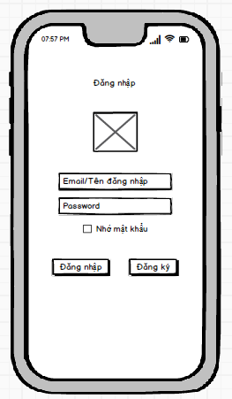

### **Require function**

|  |  |  |  |
| --- | --- | --- | --- |
| **Item** | **Description** | **Behavior** | **Response** |
| **Login screen** | Login screen has:  - Logos  - “Username” textinput      - “Password” textinput  - “Login” button  - “Register” button | N/A | N/A |
| **“Username” textinput** | Enter email/Username | Tab on textinput and enter your email/username | N/A |
| **“Password”textinput** | Enter password | Tab on the textinput password and enter the password. | Display the characters “*” |
| **“Login” button** | After filling in the username/password, click login to enter the home page. | Tab  “Login” button | -        If the username and password exist, the system will redirect to the home page  -        If the username and password do not exist, the login failed message will be displayed |
| **“Register” button** | If you do not have an account, Click the “Register” button to create an account. | Tab “Register” button | Switch to the registration screen |

## **Features / Components: Registration Screen**

### **User interface**

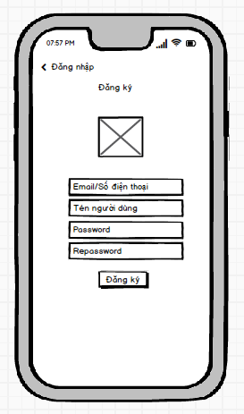

### **Require function**

|  |  |  |  |
| --- | --- | --- | --- |
| **Item** | **Description** | **Behavior** | **Response** |
| **Register screen** | The registration screen has:  - Return to the login screen  - Username  - Username  - Password  - Repassword  - "Register button" | N/A | N/A |
| **”Đăng nhập” button** | Return to the login screen | Tab “Dang nhap” | Go to login screen |
| **“Username” textinput** | Enter email/Username | Tab on textinput and enter your email/username | Display the characters you have entered |
| **“Username” textinput** | Enter username | Tab on textinput and username | Display the characters you have entered |
| **“Password”textinput** | Enter password | Tab on the textinput password and enter the password. | Display the characters “*” |
| **“Repassword”textinput** | Re-enter password | Tab  on the textinput Repassword and enter the password. | Display the characters “*” |
| **'Register' button** | Register an account | Tab to register | -        If the registered phone number already exists, the message “Existing” will be displayed.  -        If the phone number is not registered, the account will be successfully created |

## **Features / Components: Main Interface Screen**

### **User interface**

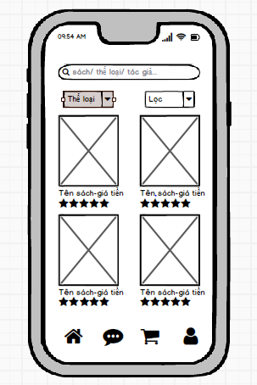

### **Require function**

|  |  |  |  |
| --- | --- | --- | --- |
| **Item** | **Description** | **Behavior** | **Response** |
| **Main interface screen** | The main interface screen includes:  - Search bar  - “Type”cobobox  -  “Filter” cobobox  - Book products  - House icon  - Message icon  - Shopping cart icon  - Human Icons | N/A | N/A |
| **Search bar** | Used to search for books. Search by entering book title/author/genre. | Tab on the search bar. | Display books related to the searched keyword |
| **“Type” cobobox** | Select the type of book that the customer wants | Tab and select | Display the kind of books according to the customer's choice |
| **“Filter”cobobox** | Filter by price, ther type... | Tab and select | Display books according to customer's choice |
| **“Latest” Button** | Use to view newly updated books | Tab | Show latest books |
| **“Genre” Button** | Display Books by selected genre | Tab to select a category | Display books by selected genre |
| **“All” Button** | Use to view all types of books | Tab | Show all types of books |
| **View product information** | View book details | Tab on any book | Switch to book details screen |
| **House Icons** | Main interface screen | Tab on the house icon. | Display the main interface screen |
| **Message icon** | Used to send messages to ask about Book information | Tab on the message icon | Switch to the message screen |
| **Shopping cart icon** | Use to view unpaid books | Tab on the cart icon | Switch to cart screen |
| **People Icons** | Used to view user information | Tab on the person icon | Switch to the screen containing the user's personal information |

## **Features / Components: Book Details Screen**

### **User interface**

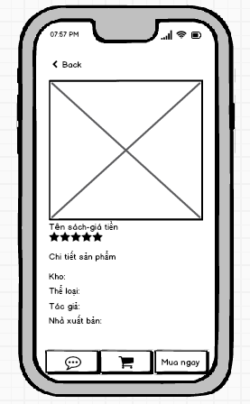

### **Require function**

|  |  |  |  |
| --- | --- | --- | --- |
| **Item** | **Description** | **Behavior** | **Response** |
| **Book Details Screen** | The Book Details Screen includes: | **N/A** | **N/A** |
| **Back** | Used to return to the main interface screen | Click on | Return to the main interface screen |
| **Image** | See pictures of the book | N/A | N/A |
| **Product details** | View information about books: Warehouse, genre, author, publisher. | N/A | Accurately display book information |
| **Message icon** | Used to text and ask about books. | Click on the message icon | Switch to the message screen |
| **Shopping cart icon** | Use to add books to cart | Click on the cart icon | The book is moved to the shopping cart. |
| **“Buy Now” button** | Use to buy immediately without having to put in the cart | Click on | The system will add to the order item and only order this 1 book |

## **Features / Components: Message Screen Asking About Book TT**

### **User interface**

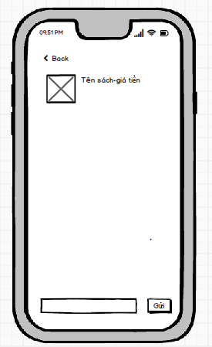

### **Require function**

|  |  |  |  |
| --- | --- | --- | --- |
| **Item** | **Description** | **Behavior** | **Response** |
| **Messenger screen** | Messenger screen has:   * Back * Bar to enter questions * “Send” button | N/A | N/A |
| **Back** | Return to details screen | Tab on | Return to details screen |
| **Bar to enter questions** | Used to enter the content of the question that needs to be asked to the admin | Tab and enter text | Text display |
| **“Send” button** | Used to send the text you just entered to the admin | Tab on | Send text to admin |

## **Features / Components: Cart Display**

### **User interface**

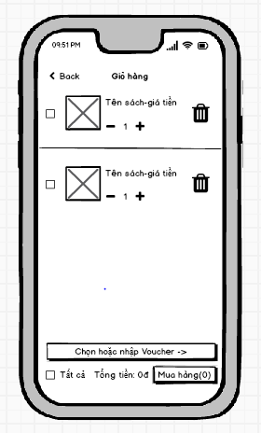

### **Require function**

|  |  |  |  |
| --- | --- | --- | --- |
| **Item** | **Description** | **Behavior** | **Response** |
| **Cart screen** | Cart screen has:   * Back * Check box * Quantity * Trash icon * Select or enter Voucher * Checkbox all * Total amount * “Purchase” Button | N/A | N/A |
| **Back** | Used to return to the main interface screen | Tab on | Return to the main interface screen |
| **Check box** | When a customer clicks on this checkbox, this book has been selected for payment | Tab on the checkbox | The book is selected and the checkbox shows a check mark |
| **Quantity** | Used to increase or decrease the number of books, and when increasing or decreasing, the amount will increase and decrease | Tab + to increase, - to decrease | The amount increases and decreases according to the quantity |
| **Trash icon** | Used to remove books from cart | Tab on the trash | Deleted books no longer exist in cart |
| **Select or enter Voucher** | Used to select discount codes | Tab on | Switch to voucher screen |
| **Checkbox all** | Use the title to select all books for payment | Tab on | All the books in the cart are selected |
| **Total amount** | Display the payment amount corresponding to the selected book, Discount Voucher | N/A | Show the exact amount |
| **“Purchase” Button** | Used to pay for selected books | Tab on | The order will be forwarded to the order checker. |

## **Features / Components: Purchase Screen**

### **User interface**

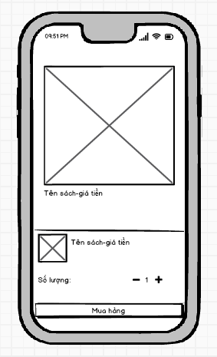

### **Require function**

|  |  |  |  |
| --- | --- | --- | --- |
| **Item** | **Description** | **Behavior** | **Response** |
| **Image** | See pictures of the book | N/A | Display selected book image |
|  | Used to increase or decrease the number of books, and when increasing or decreasing, the amount will increase and decrease | Click + to increase, - to decrease | The amount increases and decreases according to the quantity |
| **“Purchase” button** | When the customer clicks on the purchase, the book will be paid for | Click on | Books are paid |

## **Features / Components: Order Information Screen**

### **User Interface**

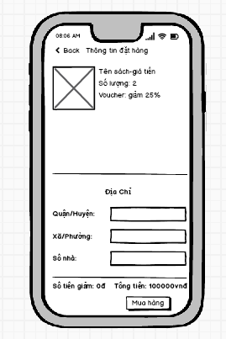

### **Require function**

|  |  |  |  |
| --- | --- | --- | --- |
| **Item** | **Description** | **Behavior** | **Response** |
| **Order information screen** | Order information screen has:   * Back * Text input “District/district” * Text input “Commune/Ward” * Text input “Street” * “buy” Button * Total amount * Reduction amount * “Purchase” Button | N/A | N/A |
| **Back** | Used to return to the shopping cart screen | Tab and enter | Back to cart screen |
| **Text input “District/district”** | Used for customers to enter the district/county that the customer needs to deliver | Tab and enter | Show Districts |
| **Text input “Commune/Ward”** | Used for customers to enter the commune/ward that the customer needs to deliver | Tab and enter | Show commune/ward |
| **Text input “Street”** | Used for customers to enter the route that the customer needs to deliver | Tab and enter | Road display |
| **“buy” Button** | Used to pay and save order information | Tab | The order is paid and sent to the admin's place of order |
| **Total amount** | Display the payment amount corresponding to the selected book, Discount Voucher | Display | Show the exact total amount |
| **Reduction amount** | According to the discount code, the customer can get the corresponding amount of discount | Display | Show the exact Reduction amount |
| **“Purchase” Button** | Used to pay for selected books | Tab | The order will be forwarded to the order checker. |

## **Features / Components: Voucher Screen**

### **User interface**

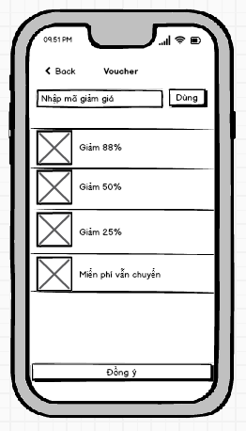

### **Require function**

|  |  |  |  |
| --- | --- | --- | --- |
| **Item** | **Description** | **Behavior** | **Response** |
| **Voucher Screen** | Voucher screen has:   * Back * Vouchers * Bar to enter discount code * “Use” button * “Agree” button | N/A | N/A |
| **Back** | Used to return to the shopping cart screen | Tab on | Back to cart screen |
| **Vouchers** | Used to reduce the corresponding price according to the content of each voucher | Tab on the voucher | Discount according to the content of the Voucher |
| **Bar to enter discount code** | Use the discount code provided by the admin. | Tab and enter the code | N/A |
| **“Use” button** | When customers have finished entering the code, click "Use" and the voucher will be applied | Tab on | Return to cart, apply to order |
| **“Agree” button** | When the customer clicks on the available voucher and then clicks agree, the voucher will be applied | Tab on | Return to cart, apply to order |

## **Features / Components: Customer Information Screen**

### **User interface**

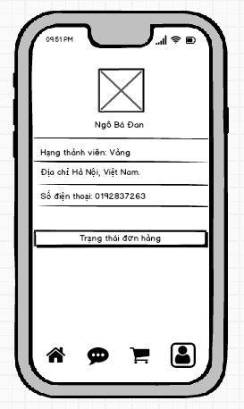

### **Require function**

|  |  |  |  |
| --- | --- | --- | --- |
| **Item** | **Description** | **Behavior** | **Response** |
| **Customer Information Screen** | Customer Information Screen has:   * Image * Full name * Membership class * Address * Tel * House icon * Messeger icon * Cart icon * People icon | N/A | N/A |
| **Image** | Customer's picture | N/A | Show pictures of customers |
| **Full name** | Show customer's first and last name | N/A | Show customer's first and last name |
| **Membership class** | It depends on the number of times that the customer buys a book, and the customer is promoted by the admin by levels: Bronze, Silver, Gold, Diamond | N/A | Show the corresponding member row |
| **Address** | Customers need to provide correct address for smooth delivery | N/A | Show address |
| **Tel** | Customers need to provide correct phone number for smooth delivery | N/A | Show phone number |
| **House Icons** | Main interface screen | Tab on the house icon. | Display the main interface screen |
| **Message icon** | Used to send messages to ask about Book information | Tab on the message icon | Switch to the message screen |
| **Shopping cart icon** | Use to view unpaid books | Tab on the cart icon | Switch to cart screen |
| **People Icons** | Used to view user information | Tab on the person icon | Switch to the screen containing the user's personal information |

## **Features / Components: Delivery Status Screen**

### **User interface**

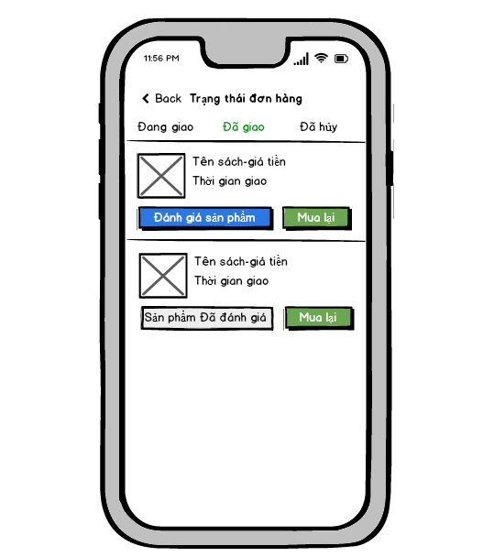

### **Require function**

|  |  |  |  |
| --- | --- | --- | --- |
| **Item** | **Description** | **Behavior** | **Response** |
| **Delivery Status Screen** | Delivery Status Screen has:   * Back * Delivery Status Screen * Delivering * Delivered * Cancelled * No orders yet * Image * Product details * Product Review Button * Buy Back Button | N/A | N/A |
| **Back** | Used to return to customer information screen | Tab on | Return to customer information screen |
| **Wait for confirmation** | If the customer has an order to confirm, the order will be in a position waiting for confirmation | Tab on | Show orders pending confirmation |
| **Delivering** | On delivery means the order is in transit | Tab on | Show orders being shipped |
| **Delivered** | Delivered means the order has been delivered to the customer | Tab on | Show delivered orders |
| **Cancelled** | Canceled order canceled for some reason | Tab on | Show canceled orders |
| **No orders yet** | When this text appears in any order status, it means that the order status has no orders | N/A | N/A |
| **Image** | See pictures of the book | N/A | N/A |
| **Product details** | View information about books: Warehouse, genre, author, publisher. | N/A | Switch to the screen that shows the correct information about the book |
| **Product Review Button** | Counterfeit products that customers have purchased and received | N/A | Switch to product review screen |
| **Buy Back Button** | Buy back products that have already been purchased | N/A | Switch to cart screen and add products to cart |

## **Features / Components: Product Review Screen**

### **User interface**

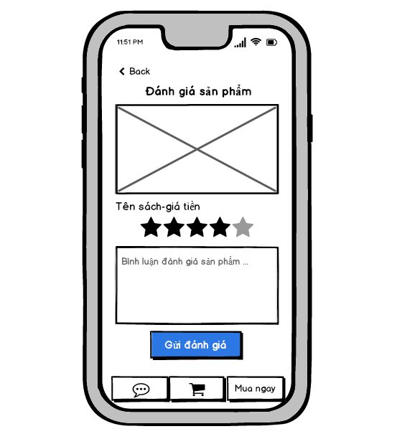

### **Require function**

|  |  |  |  |
| --- | --- | --- | --- |
| **Item** | **Description** | **Behavior** | **Response** |
| **Product Review Screen** | Product Review Screen has:   * Back * Image * Product details * Star rating * Product Comments * Button Submit Review * Message icon * Shopping cart icon * “Buy Now” button | N/A | N/A |
| **Back** | Used to return to the main interface screen | Tab on | Return to the product delivery status screen |
| **Image** | See pictures of the book | N/A | N/A |
| **Product details** | View information about the book: Book title, price, etc. | N/A | Accurately display book information |
| **Star rating** | Rated by the number of stars from left to right, the number of stars is based on the customer's love for the product | N/A | The number of stars changes color from left to right based on the star point that the customer clicks on |
| **Product Comments** | Customer reviews enter the information that the customer wants to comment | Tab and enter | Enter the information that the customer comments |
| **Button Submit Review** | The customer clicks the submit review button and completes the product review | Tab on | Submit and save customer reviews |
| **Message icon** | Used to text and ask about books. | Tab on the message icon | Switch to the message screen |
| **Shopping cart icon** | Use to add books to cart | Tab on the cart icon | The book is moved to the shopping cart. |
| **“Buy Now” button** | Use to buy immediately without having to put in the cart | Tab on | The system will add to the order item and only order this 1 book |

## **Features / Components: Login Screen**

### **User interface**

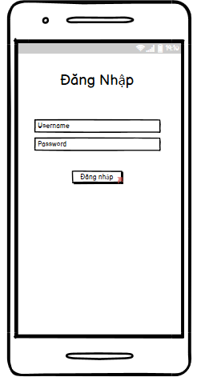

### **Require function**

|  |  |  |  |
| --- | --- | --- | --- |
| **Item** | **Description** | **Behavior** | **Response** |
| **Login Screen** | The login screen includes:  -         “username” edittext  -         “password” edittext  -        “login” button  -          “Login” textview | N/A | N/A |
| **“Username” edittext** | Enter Username | Tap on | Display the keyboard and the user can input |
| **“Password” edittext** | Enter Password | Tap on | Display the keyboard and the user can input |
| **“Login” textview** | Display the name of the screen | N/A | N/A |
| **“Login” button** | If Username and Password exist correctly in the database, it will go to the Home screen | Tap on | Go to Home Screen |
| If the Username and Password do not exist correctly in the database, a dialog box will be displayed with the content “Invalid Username or Password” and “OK” button. | Tap on | A pop up is showed |
| “OK” button closes the notification dialog | Tap on | Pop up is closed |

## **Features / Components: Home Screen**

### **User interface**

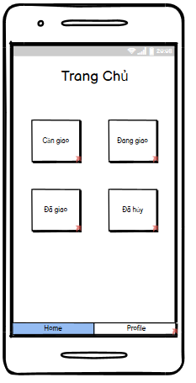

### **Require function**

|  |  |  |  |
| --- | --- | --- | --- |
| **Item** | **Description** | **Behavior** | **Response** |
| **Home Screen** | The Home screen includes:  -        “Need Delivery” button  -        “Delivering” button  -        “Delivered” button  -        “Canceled” button  -        “Home” tab  -        “Profile” tab  -        “Home” textview | N/A | N/A |
| **“Need delivery” button** | “Need delivery” button to navigate to the Orders to be delivered screen | Tap on | Navigate to the Orders to be delivered screen |
| **“Delivering” button** | “Delivering” button to navigate to the Orders being delivered screen | Tap on | Navigate to the Orders being delivered screen |
| **“Delivered” button** | “Delivered” button to navigate to the Delivered Orders screen | Tap on | Navigate to the Delivered Orders screen |
| **“Canceled” button** | “Cancelled” button to navigate to Canceled Order screen | Tap on | Navigate to the Canceled Orders screen |
| **“Profile” tab** | “Profile” tab to navigate to the profile screen | Tap on | Navigate to the profile screen |
| **“Home” tab** | “Home” tab to navigate to the home screen | Tap on | Navigate to the home screen |
| **“Home” textview** | Display the name of the screen | N/A | N/A |

## **Features / Components: Orders to be delivered**

### **User interface**

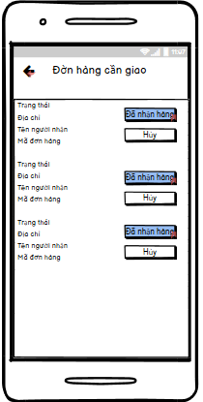

### **Require function**

|  |  |  |  |
| --- | --- | --- | --- |
| **Item** | **Description** | **Behavior** | **Response** |
| **"Order to be delivered" screen** | The "Order to be delivered" screen includes:  -        “icon arrow-left” button  -          Listview | N/A | N/A |
| **“icon arrow-left” button** | Back to the Home screen | Tap on | Back to the Home screen |
| **“Order to be delivered” listview** | Display order information to be delivered including:   * Status * Address * Recipient's name * Code orders * “Cancel” button * “Received” button | Tap on “Received” button | Navigate to the Orders being delivered screen.  The order will be removed from the list and The order goes to the Orders being delivered screen |
| Tap on “Cancel” button | Confirm that the Shipper is busy and the order will be removed from the list |

## **Features / Components: Orders Being Delivered Screen**

### **User interface**

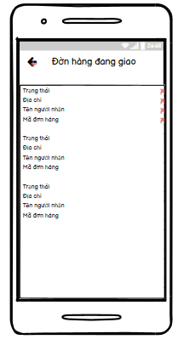

### **Require function**

|  |  |  |  |
| --- | --- | --- | --- |
| **Item** | **Description** | **Behavior** | **Response** |
| **Orders Being Delivered Screen** | The Orders being delivered screen includes:  -        “icon arrow-left” button  -        Listview | N/A | N/A |
| **“icon arrow-left” button** | Back to the Home screen | Tap on “Arrow-left” | Back to the Home screen |
| **'Orders being delivered' listview** | Display information about orders being delivered, including: “  -        Status  -        Address  -        Recipient's name  -        Code orders  " | N/A | N/A |
| Tap on an item will go to the Order Details screen | Tap on | Navigate to the Order Details screen |

## **Features / Components: Order Details Screen**

### **User interface**

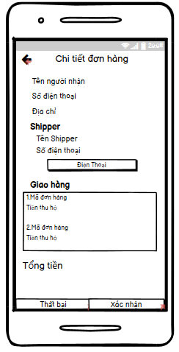

### **Require function**

|  |  |  |  |
| --- | --- | --- | --- |
| **Item** | **Description** | **Behavior** | **Response** |
| **Order Details screen** | The Order Details screen includes:  -        “icon arrow-left” button  -        “Recipient Name” label  -        “Phone number” label  -        “Address” label  -        “Shipper Name” label  -        “Shipper phone number” label  -        “Phone” button  -        Listview  -        “Confirm” button  -        “Fail” button  -        “Shipper” textview  -        “Delivery” textview  -    “Total amount” label | N/A | N/A |
| **“icon arrow-left” button** | Back to the Orders being delivered screen | Tap on | Back to the Orders being delivered screen |
| **“Recipient Name” label** | Display “recipient name” on the screen | N/A | N/A |
| **“Phone number” label** | Display “phone number” on the screen | N/A | N/A |
| **“Address” label** | Display “address” on the screen | N/A | N/A |
| **“Shipper Name” label** | Display “shipper name” screen | N/A | N/A |
| **“Shipper phone number” label** | Display “shipper phone number” screen | N/A | N/A |
| **“Phone” button** | Exit the app and show the phone number on the phone app | Tap on “Phone” | Exit the app and open the phone app |
| **“Delivery” listview** | Display the list of orders of the recipient including: “  -           Code orders  -          Collected money  " | N/A | N/A |
| **“Total amount” label** | Display the total amount of the orders of each recipient | N/A | N/A |
| **“Confirm” button** | The order is in transit, it has been delivered and it will go to the delivered order screen | Tap on | Navigate to the Delivered Orders screen |
| **“Fail” button** | Switch to the Failure Reason screen | Tap on | Navigate to the Failure Reason screen |
| **“Shipper” textview** | Display “Shipper” textview to the screen | N/A | N/A |
| **“Delivery” textview** | Display “Delivery” textview to the screen | N/A | N/A |

## **Features / Components: Delivered Order Screen**

### **User interface**

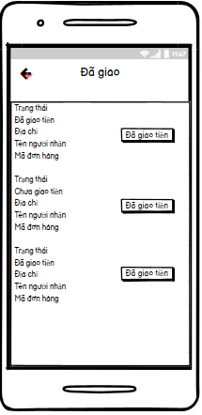

### **Require function**

|  |  |  |  |
| --- | --- | --- | --- |
| **Item** | **Description** | **Behavior** | **Response** |
| **Orders Delivered Screen** | The Delivered Orders screen includes:  -        “icon arrow-left” button  -        Listview | N/A | N/A |
| **“icon arrow-left” button** | Back to the Home screen | Tap on “Arrow-left” | Back to the Home screen |
| **'Order delivered' listview** | Displays information about orders that have been delivered, including the following information:   * Status * Money has/haven't been delivered * Address * Recipient's name * Code orders * Money delivered button | Tap on Money delivered button | Confirm that the Shipper has delivered the money to the store |

## **Features / Components: Canceled Order Screen**

### **User interface**

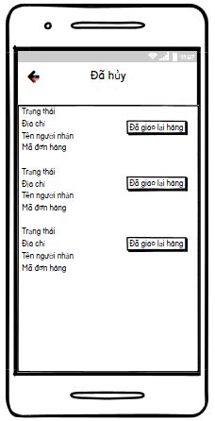s

### **Require function**

|  |  |  |  |
| --- | --- | --- | --- |
| **Item** | **Description** | **Behavior** | **Response** |
| **Canceled Orders screen** | The Canceled Orders screen includes:  -        “icon arrow-left” button  -        Listview | N/A | N/A |
| **“icon arrow-left” button** | Back to the Home screen | Tap on “Arrow-left” | Back to the Home screen |
| **'canceled order ' listview** | Displays information about orders that have been delivered, including the following information:   * Status * Address * Recipient's name * Code orders * redelivered button | Tap on redelivered button | The canceled order confirmation is returned to the store and the order will be deleted upon confirmation |

## **Features / Components: Profile Screen**

### **User interface**

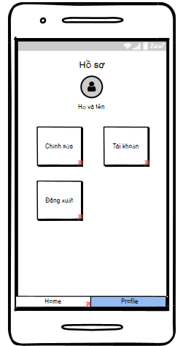

### **Require function**

|  |  |  |  |
| --- | --- | --- | --- |
| **Item** | **Description** | **Behavior** | **Response** |
| **Profile Screen** | The Profile screen includes:  -        “Shipper Name” label  -         “Log Out” button  -        “Edit” button  -        “Avatar” image  -        “Home” tab  -        “Profile” tab  -        “Account” button  -        “Profile” textview | N/A | N/A |
| **“Shipper Name” label** | Display “first and last name of shipper” on the screen | N/A | N/A |
| **“Log Out” button** | Tap on“Log Out” the account will exit and go to the Login screen | Tap on | Go to the Login screen |
| **“Avatar” image** | Show Shipper .'s profile photo | N/A | N/A |
| **“Edit” button** | Navigate to Edit Profile screen | Tap on | Navigate to Edit Profile screen |
| **“Home” tab** | Navigate to the Home screen | Tap on | Navigate to the Home screen |
| **“Profile” tab** | Navigate to Profile screen | Tap on | Navigate to Profile screen |
| **“Account” button** | Navigate to the Account Management screen | Tap on | Navigate to the Account Management screen |

## **Features / Components: Account Management Screen**

### **User interface**

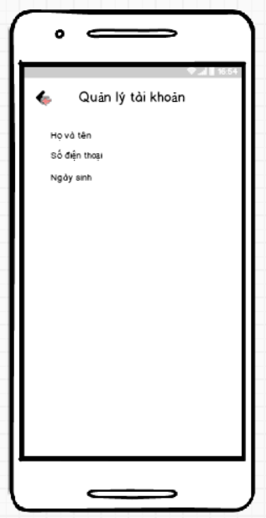

### **Require function**

|  |  |  |  |
| --- | --- | --- | --- |
| **Item** | **Description** | **Behavior** | **Response** |
| **Account Management screen** | The Account Management screen includes:  -        “icon arrow-left” button  -        “Full name” label  -        “Phone number” label  -        “Address” label  -        “Date of Birth” label | N/A | N/A |
| **“Full name” label** | Show first and last name Shipper | N/A | N/A |
| **“Phone number” label** | Show Shipper's phone number | N/A | N/A |
| **“Address” label** | Show Shipper's address | N/A | N/A |
| **“Date of Birth” label** | Show Shipper's date of birth | N/A | N/A |
| **“icon arrow-left” button** | Back to Profile screen | Touch | Back to Profile screen |

## **Features / Components: Edit Profile Screen**

### **User interface**

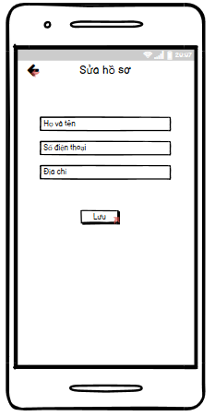

### **Require function**

|  |  |  |  |
| --- | --- | --- | --- |
| **Item** | **Description** | **Behavior** | **Response** |
| **Edit Profile Screen** | The Edit Profile screen includes:  -        “Full name” edittext  -        “Phone number” edittext  -        “Address” edittext  -        “Update” button  -        “icon arrow-left” button | N/A | N/A |
| **“Full name” edittext** | Enter Shipper's First and Last Name | Tap on | Display the keyboard and enter the shipper's name |
| **“Phone number” edittext** | Enter Shipper's Phone Number | Tap on | Display the keyboard and enter the shipper's phone number |
| **“Address” edittext** | Enter Shipper's Address | Tap on | Display the keyboard and enter the address of the shipper |
| **“Save” button** | Used to save the information entered by the user in the edittext and navigate to the Profile screen | Tap on | Navigate to the Profile screen |
| **“icon arrow-left” button** | Back to Profile screen | Tap on | Back to the Profile screen |

## **Features / Components: Delivery Failure Reason Screen**

### **User interface**

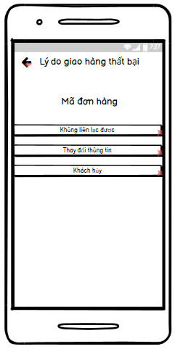

### **Require function**

|  |  |  |  |
| --- | --- | --- | --- |
| **Item** | **Description** | **Behavior** | **Response** |
| **Delivery Failure Reason screen** | The Delivery Failure Reason screen includes:  -        “icon arrow-left” button  -         “Code orders” label  -        “Cannot be contacted” button  -        “Change information” button  -        “Customer cancel” button | N/A | N/A |
| **“icon arrow-left” button** | Back to Order Details screen | Tap on “Arrow-left” | Back to Order Details screen |
| **“**c**ode orders” label** | Display “code orders” on the screen | N/A | N/A |
| **“Cannot be contacted” button** | Navigate to the Reason for unreachable screen | Tap on | Navigate to the Reason for unreachable screen |
| **“Change information” button** | Navigate to the Information Change Reason screen | Tap on | Navigate to the Information Change Reason screen |
| **“Customer cancel” button** | Navigate to the Reason for cancellation screen | Tap on | Navigate to the Reason for cancellation screen |

## **Features / Components: Reason for unreachable Screen**

### **User interface**

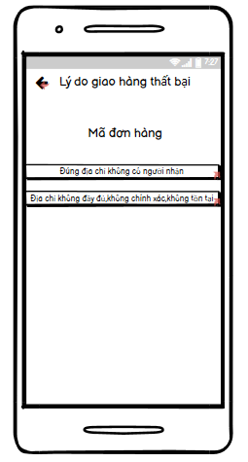

### **Require function**

|  |  |  |  |
| --- | --- | --- | --- |
| **Item** | **Description** | **Behavior** | **Response** |
| **The Reason for Unreachable Screen”** | The Reason for Unreachable screen includes:  -        “icon arrow-left” button  -         “code orders” label  -        “Right address no recipient” button  -        “The address is incomplete, incorrect, does not exist” button | N/A | N/A |
| **“icon arrow-left” button** | Back to the Delivery failure reason screen | Tap on | Back to the Delivery failure reason screen |
| **“Order number” label** | Display “code orders” on the screen | N/A | N/A |
| **“Right address no recipient” button** | Navigate to the Delivery Failure Confirmation screen | Tap on | Navigate to the “Delivery Failure Confirmation” screen |
| **“The address is incomplete, incorrect, does not exist” button** | Navigate to the Delivery Failure Confirmation screen | Tap on | Navigate to the Delivery Failure Confirmation screen |

## **Features / Components: Information Change Reason Screen**

### **User interface**

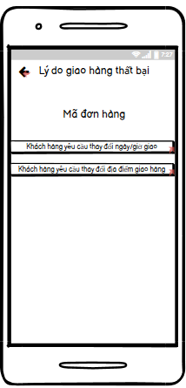

### **Require function**

|  |  |  |  |
| --- | --- | --- | --- |
| **Item** | **Description** | **Behavior** | **Response** |
| **Information Change Reason screen** | The Information Change Reason screen includes:  -        “icon arrow-left” button  -         “Code orders” label  -        “Customer requests to change delivery date and time” button  -        “Customer requests to change delivery location” button | N/A | N/A |
| **“icon arrow-left” button** | Back to the Delivery failure reason screen | Tap on | Back to the Delivery failure reason screen |
| **“Code orders” label** | Display “code orders” on the screen | N/A | N/A” |
| **“Customer requests to change delivery date and time” button** | Tap on it, it will go to the screen “Confirm failed delivery” | Tap on | Navigate to the Confirm Delivery Failed screen |
| **“Customer requests to change delivery location” button** | Tap on it, it will go to the screen “Confirm failed delivery” | Tap on | Navigate to the Confirm Delivery Failed screen |

## **Features / Components: Customer Cancellation Reason Screen**

### **User interface**

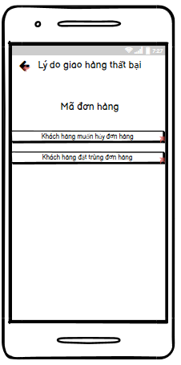

### **Require function**

|  |  |  |  |
| --- | --- | --- | --- |
| **Item** | **Description** | **Behavior** | **Response** |
| **Cancellation reason screen** | The Customer Cancellation Reason screen includes:  -        “icon arrow-left” button  -         “Code orders” label  -        “Customer wants to cancel the order” button  -        “Customer placed the same order” button | N/A | N/A |
| **“icon arrow-left” button** | Back to the Delivery failure reason screen | Tap on | Back to the Delivery failure reason screen |
| **“Order number” label** | Display “code orders” on the screen | N/A | N/A |
| **“Customer wants to cancel the order” button** | Navigate to the Delivery Failure Confirmation screen | Tap on | Navigate to the Delivery Failure Confirmation screen |
| **“Customer placed the same order” button** | Navigate to the Delivery Failure Confirmation screen | Tap on | Navigate to the Delivery Failure Confirmation screen |

## **Features / Components: Delivery Failure Confirmation Screen**

### **User interface**

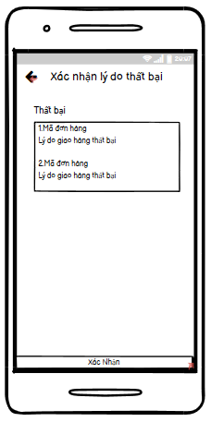

### **Require function**

|  |  |  |  |
| --- | --- | --- | --- |
| **Item** | **Description** | **Behavior** | **Response** |
| **Delivery Failure Confirmation Screen** | The Delivery Failure Confirmation screen includes:  -        “icon arrow-left” button  -        “Failure” listview  -         “Confirm” button  -        “Failure” textview | N/A | N/A |
| **“icon arrow-left” button** | Back to the previous screen | Tap on “Arrow-left” | Back to the screen The reason for the customer to cancel |
| Back to the information change screen |
| Back to the unreachable screen |
| **“Failure” listview** | Display a list of canceled orders including:  "  -        Code orders  -        Reason for delivery failure  " | N/A | N/A |
| **“Confirm” button** | Confirm the order has been canceled and will go to the Canceled order screen | Tap on | Navigate to Canceled Orders screen |
| **“Failure” textview** | Display “Failure” textview to the screen | N/A | N/A |